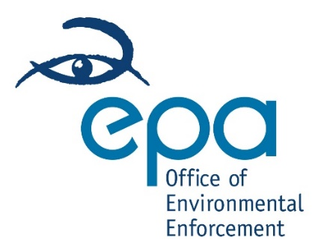
EEE Producer Compliance Concern Form
This form can be used to raise a concern to the EPA about a producer of electrical or electronic equipment (EEE) who is not fully registered with the Producer Register Limited in accordance with the WEEE Directive.
If you are concerned that a person or business is selling EEE which has not come from a registered producer, please provide the information requested below. You do not have to provide your own contact details, but if you do, they will be held as confidential and will not be shared with anyone unless you request it and will allow us to update you as to the outcome of any further investigations.
- Your Details (you are not obliged to provide these)
Name:
Phone number:
Email address:
- Your compliance concern
Name of company:
Company address:
- Your evidence
Provide evidence such as screen shots, copies of bills, delivery notes, proof of sale, etc. (include attachments, as necessary)
When? | What
Where? | Anything else?

- How to submit your form.
Please submit your completed form by email to the address weee@epa.ie with the text ‘EEE producer compliance concern form’ and the company name in the subject box.
By submitting this form, you are confirming the information you provide to be accurate and true.
Date:

