LICENCE REFERENCE No. | RISK ASSESSMENT METHODOLOGY STAGE & STEP |  | REPORT VERSION
Insert licence reference number | Insert methodology stage and step, e.g. Stage 2 |  | Insert report version no., e.g. Draft, Final
INSERT COMPANY LOGO/HEADER
Guideline Template for Corrective Action Feasibility & Design Report
for the Environmental Protection Agency
(Month Year)
(LICENCE No.)

INSTRUCTIONS on use of this template
                - This document presents a guideline reporting template for stakeholders to use when reporting Corrective Action Feasibility and Design under the EPA Contaminated Land & Groundwater Risk Assessment Methodology. It is designed to assist stakeholders with the submission of the correct information in a suitable format to the EPA. It should be regarded as a comprehensive guide; it is not intended to be a wholly prescriptive template.
                - Where there are deficiencies or uncertainties in the information provided these should be clearly marked and annotated to indicate where further data gathering may be required.
                - In the template, those parts written in red indicate where relevant information and/or assessment should be entered. In entering this information the red text should be deleted or written over and the text reformatted to normal style.
                - For a glossary of terms and acronyms used in this template report and for a list of key technical guidance documents, refer to the ‘Guidance on the Management of Contaminated Land and Groundwater at EPA Licensed Sites’ (EPA, 2013).
                - Delete this page before submitting this report to the EPA.

Project Title: |  | Corrective Action Feasibility & Design Report
Licence No: |  | (complete)
Project No: |  | (complete)
Contract No: |  | (complete)
Report Ref: |  | (complete)
Status: |  | (Draft/2nd Draft/Final (examples))
Client: |  | (complete)
Client Details: |  | (complete)
Issued By: |  | (Consultancy company name and address)
Document Production/Approval Record
 | Name |  | Signature | Date | Position | % Input
Prepared by (consultant) | Insert here |  | Insert here | Insert here | Insert here | Insert here
Approved by (consultant) | Insert here |  | Insert here | Insert here | Insert here | Insert here
Site Approval by | Insert here |  | Insert here | Insert here | Insert here | N/A

Limitation
All limitations that apply to the work should be summarised here, including reference to the original proposal for the work and the originally proposed project objectives and scope of works. State if these were achieved and the scope of works completed. Where the scope deviated significantly from the originally proposed scope, this should be summarised herein (if a limitation). State the limit of liability, reliance etc., that apply to this project.
                - TABLE OF contents
Section |  |  | Page No
Executive summary
1. introduction 1
1.1. PROJECT CONTRACTUAL BASIS & PERSONNEL INVOLVED 1
1.2. BACKGROUND INFORMATION from stage 1 1
1.3. Overall Project Objectives 2
1.4. SCOPE OF WORK 2
1.5. Remedial Options Assessment 2
1.6. Remedial FeasIbility Study OBJECTIVES 2
1.7. Feasibility study SCOPE OF WORKS 2
2. Conceptual site model update 2
2.1. potential pollutant linkages 2
2.2 validation of the risk assessment 3
2.3 remedial objectives & OUTLINE STRATEGY 3
3. corrective action feasibility trials 3
3.1. Trial Results & Assessment 3
3.2. Outline corrective action design 3
4. Detailed corrective action plan Design 4
5. corrective action implementation plan 4

figures (to be expected)
Figure 1 | Site location plan
Figure 2 | Site layout plan showing main buildings and infrastructure
Figure 3+ | Site investigation sampling location plans
Figure 4+ | Hydrogeological regime plans
Figure 5+ | Site plans illustrating the locations and salient features of contaminant source zones, pathways and receptors
Figure 6 | Technical illustrations of the feasibility trial results (if completed). These could include illustrations of contaminant recovery masses or composition, radii of influence of trial boreholes, etc.
Figure 7+ | Illustrations of key aspects of the corrective action design. These could include plans and sections of the areas to be treated and remedial system layout, schematics of treatment systems and pollution monitoring infrastructure.
Figure 8+ | Technical illustration presenting the updated conceptual site model (CSM) post Corrective Action Feasibility & Design and showing the pollutant linkages to be addressed (showing changes made). In all cases, the CSM should be illustrated in diagrammatic form.
Tables (to be expected)
Tables(s) |  | Depending on the task, tables presenting:  - Sample inventories  - Supporting field and/or laboratory data (if not included or referenced elsewhere)  - Generic and/or site-specific assessment criteria used for risk assessment  - Summary tables of source zone contaminant dataset screening (if used and extended by the corrective action feasibility trials)  - Any other information pertinent to the corrective action feasibility trial process  - Pertinent data included or parameters associated with the remedial design
appendices (that may be expected to be useful)
Appendix A+ |  | Appended information may include:  - Geological cross-sections and/or key borehole/monitoring well logs  - Supporting field and/or laboratory data (if not tabulated or referenced elsewhere) such as results of field trials, hydraulic conductivity testing, hydrographs, etc.  - Groundwater and/or land gas monitoring data if detail is considered useful to include and has not been explicitly summarised elsewhere  - Revisions to risk assessments that may have been required by the collection of additional data at this stage of the project

executive summary
An Executive Summary is considered necessary for all reports of any size to allow a reader to quickly understand project objectives and scope of work and all the main findings.
This must include, as a separate page within the executive summary, the latest diagrammatic Conceptual Site Model (CSM) based on data collected during this phase of the site programme of works (see attached example) and illustrating the methodologies by which the proposed corrective action programme will address the remedial objectives.
It must also include a flow chart illustrating where this report sits in the overall contaminated land and groundwater site assessment and corrective action process, confirming all aspects already completed (see attached example). It is noted that for Stage 2 the various steps may be combined into one or more reports, rather than having to submit individual reports for each step. This guideline template report broadly covers all Stage 2 steps.

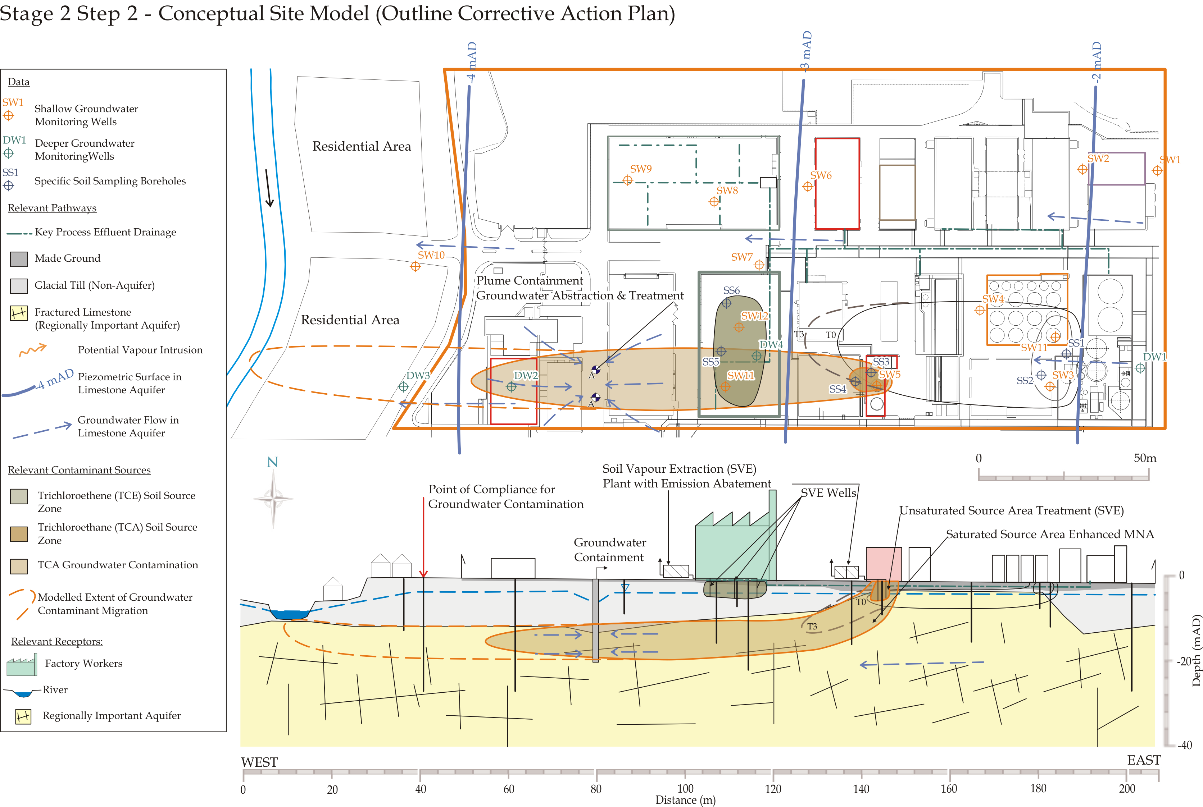

Replace this image with a diagrammatic Conceptual Site Model showing the current understanding of site circumstances.

EPA Contaminated Land & Groundwater Risk Assessment Methodology |  | Report Reference | Report Date | Status
STAGE 1: SITE CHARACTERISATION & ASSESSMENT
1.1 | PRELIMINARY SITE ASSESSMENT | (Insert previous report author & reference) | (Insert previous report date) | (Draft, Final, Approved etc.)
1.2 | DETAILED SITE ASSESSMENT | (Insert previous report author & reference) | (Insert previous report date) | (Draft, Final, Approved, etc.)
1.3 | QUANTITATIVE RISK ASSESSMENT | (Insert previous report author & reference) | (Insert previous report date) | (Draft, Final, Approved, etc.)
STAGE 2: CORRECTIVE ACTION FEASIBILITY & DESIGN
2.1 | OUTLINE CORRECTIVE ACTION STRATEGY | (Insert this report author & reference) | (Insert this report date?) | (Draft, Final, etc.)
2.2 | FEASIBILITY STUDY & OUTLINE DESIGN | (Insert this report author & reference) | (Insert this report date?) | (Draft, Final, etc.)
2.3 | DETAILED DESIGN | (Insert this report author & reference) | (Insert this report date?) | (Draft, Final, etc.)
2.4 | FINAL STRATEGY & IMPLEMENTATION PLAN | (Insert this report author & reference) | (Insert this report date?) | (Draft, Final, etc.)
STAGE 3: CORRECTIVE ACTION IMPLEMENTATION & AFTERCARE
3.1 | ENABLING WORKS
3.2 | CORRECTIVE ACTION IMPLEMENTATION & VERIFICATION
3.3 | AFTERCARE

- introduction
While there are four distinct steps to the Stage 2 process, unless a project is particularly complex, it can often make sense to undertake Stage 2 in a single phase or two phases (i.e. Steps 1 and 2 before a client/regulatory review, followed by Steps 3 and 4).
The first phase would commonly incorporate the identification of an initial corrective action strategy (Stage 2, Step 1) from the options available. The performance of feasibility studies and the preparation of an outline corrective action design would then follow.
Data is collected not only to identify the viability of a short list of remedial approaches and techniques but may also generate information that extends understanding of source area and exposure pathway characteristics. Consideration of the CSM and risk assessment validity should therefore be looked at in conjunction with appraising the viability of specific corrective action (remedial) technologies to deliver an appropriate outline corrective action design. These elements are covered by Sections 1–3 of this report template.
Following Steps 1 and 2, and likely client and regulator engagement at this time, the project typically moves on to Steps 3 and 4. These two stages deal with the detailed design (Step 3) and the final corrective action strategy and implementation plan (Step 4).
This report can be used for guidance for the whole of the Stage 2 process, whether it is completed in one or two phases and with or without regulatory and stakeholder engagement. If needed the Stage 2 report can be issued initially as an interim, working draft and later stages completed following engagement and feedback.
  - PROJECT CONTRACTUAL BASIS & PERSONNEL INVOLVED
Confirm the contractual basis for the work including the proposal reference number.
List the name and role of the main people who completed the work and their qualifications and years of experience, including the main sub-contracted elements, if applicable (e.g. sub-consultants; drilling contractor; specialist remedial contractors).
  - BACKGROUND INFORMATION from stage 1
This section should succinctly inform the reader what the report is about. It should provide the licensee/site name, its location with reference to a site map and the activity at the site.
Summarise background information relevant to the corrective action feasibility and design assessment. This should include the main findings of works completed in Stage 1. Reference these reports as required.
Detail relevant information from the Stage 1.3 Detailed Quantitative Risk Assessment (DQRA), earlier collected supporting data and the latest conceptual site model (CSM), specifically:
- Potential pollutant linkages (source–pathway–receptor relationships) to be addressed by the corrective action programme;
- The findings of the preliminary corrective action options assessment that would be expected to have appeared as outline conclusions and recommendations in the DQRA report.
Tabulate and/or append relevant information (Table xx/Appendix xx, e.g. exploratory hole logs, geological cross-sections, groundwater/land gas monitoring data, etc.) or, if presented elsewhere in previously submitted and readily available reports, clearly reference the data used (including report title, author, date, reference, figure/table/appendix number, and page).
It must be noted that reports should strike the right balance between providing enough support information to allow them to be reasonably standalone, while not repeating everything that has gone before.
  - Overall Project Objectives
This section should set out the overall objectives of the Stage 2 project or element thereof covered by this report.
  - SCOPE OF WORK
This report section should set out the scope of this report in relation to how much of the Stage 2 procedure has been included.
  - Remedial Options Assessment
This section should comprise a broad corrective action options assessment exercise, the output from which should be a shortlist of potentially viable remedial technologies that could be applied as part of the corrective action strategy for the site.
Justification for the selected approaches should be undertaken on the basis of practicability, likelihood of success in achieving the remedial objectives, costs, timescale and sustainability.
Areas of potential uncertainty associated with each of the selected corrective action options should be identified. Where these are considered to be material and can be resolved through a feasibility assessment this should be identified and included in the scope of Stage 2.2.
  - Remedial FeasIbility Study OBJECTIVES
Clearly define the objectives for the remedial feasibility studies and subsequent elements of the Stage 2 process that are included in this report.
  - Feasibility study SCOPE OF WORKS
Clearly summarise the scope of works that was developed to meet the defined remedial feasibility study objectives and if there had to be deviations from the originally planned scope, what these were. Specifically:
- Describe and justify the selection of corrective action feasibility assessment methodologies. These could include desk-based design, laboratory or site scale trials.
- Explain how these methodologies were implemented, giving details of the measurements made and referencing the location of this data in the report. Also detail any additional data gathered that could be utilised to support or amend the CSM (e.g. additional source area and pathway characterisation).
Sections 2 and 3 should be completed in tandem on concluding the remedial feasibility trials as they both draw on information gathered during this stage of the process.
- Conceptual site model update
  - potential pollutant linkages
Provide an update of the CSM and detail any additional information gathered during the feasibility trials that may have a bearing on the CSM. For example this could include:
- Additional characterisation of source areas and/or dissolved phase plumes;
- Better understanding of the pollutant linkage exposure pathways (e.g. groundwater flow regime, hydraulic conductivities, etc.);
- Changes in site conditions that could have a bearing on the potential pollutant linkages.
The data should be presented using tabular summaries and drawings illustrating the revised understanding gained. Where these are materially different to those site conditions that underpin the previous Stage 1 risk assessment, then it will be necessary to revisit the risk assessment and provide an update in this report. Any changes to the risk assessment input parameters should be clearly identified and justified

2.2 validation of the risk assessment
This section either should provide a justification for the previous risk assessment (i.e. where no material changes to the conditions or assumptions that underpin the previous risk assessment have been identified) or it should identify what changes to the risk assessment are required in the light of newly gathered data.
Details should be provided as an appendix to this report including all revisions to the previous risk assessment. A summary of this should be provided as part of the main text herein. Overall the level of detail provided to support any changes should be commensurate with the requirements set out in the Stage 1.3 report template. If the changes are substantial then the best approach may be to re-issue the Stage 1 DQRA report once it has been updated.

2.3 remedial objectives & OUTLINE STRATEGY
The output of the CSM update and risk assessment validation exercise should be a defined set of remedial objectives for the site and those elements of the corrective action strategy that are designed to address these.
The remedial objectives should be defined clearly, related to the specific pollutant linkages that they are designed to address and the element(s) of the corrective action that will be used to achieve them.
Wherever possible the objectives should be set in a manner that allows compliance to be demonstrated on completion of the corrective action works. Compliance point location(s) and methods of measurement should be described and justified.
- corrective action feasibility trials
  - Trial Results & Assessment
This section of the report should include a detailed presentation of the corrective action (remedial) feasibility trials undertaken for the site. The description should reference appended data, and utilise summary tables and drawings to assist data presentation.
An assessment of the results should be made in terms of the degree to which specific issues of uncertainty around the viability of a particular technique have been resolved by the trials, and the implications these have for the full-scale implementation.
Identify aspects of the results that point to:
- The likelihood of the trialled technology meeting or failing to meet the remedial objectives, and;
- Aspects of uncertainty that have not been resolved by the remedial trials.
Where the remedial trials indicate that a particular remedial option is unlikely to succeed in achieving the remedial objectives, or where there is significant uncertainty in this regard, then state the reasons for this conclusion. The report should go on to detail the proven, feasible and/or alternative approaches that are proposed to meet the remedial objectives.
  - Outline corrective action design
This section should summarise the key aspects of the proposed corrective action plan for the site. The level of detail provided should include:
- A description of the remedial technologies included and their suitability to the tasks proposed;
- An illustration of the locations of key infrastructure included within the design;
- Details of the pollution control and monitoring measures to be employed;
- Planning control, regulatory licensing and discharge consent requirements;
- Indications of power supply requirements and availability;
- Key design parameters as appropriate to the works in question. These could include estimated contaminant recovery rates; contaminated media extraction rates (e.g. groundwater, soil vapour).
- Detailed corrective action plan Design
This section should be completed once approval of the outline remedial design has been received and any outstanding queries resolved. This section should not only incorporate the necessary level of detail to procure the work but also incorporate measures to be included in the overall corrective action plan that allow:
- Quality control to be demonstrated in relation to the corrective action plan implementation;
- Management of change in terms of the Conceptual Site Model that may arise during implementation of the corrective action plan and that need to be accounted for so as to achieve the overall remedial objectives;
- Compliance with relevant licences and discharge consents including control of emissions to the wider environment (e.g. noise and odour abatement, dust and vapour control, treatment of water discharges);
- Management of the remedial technology to assess its progress towards achieving the remedial objectives and allow adjustment of the process to optimise performance;
- Quantitative measurement of the remedial works to validate their performance against the remedial objectives for the site.
The detailed design section should include sufficient technical detail to address each of these aspects within the corrective action plan.
- corrective action implementation plan
This section should incorporate information relevant to the proposed implementation of the works. The following elements should form the basis for the implementation plan:
- Who will undertake each aspect of the implementation, i.e. installation, monitoring, maintenance, management, sample analysis, etc.;
- How long each aspect will take to complete;
- Which regulatory permits will be required;
- Which technical specifications and/or contracts will be used to deliver the remediation strategy;
- A detailed monitoring programme sufficient to verify that the corrective action programme is progressing as designed;
- Contingency plans;
- Verification monitoring plan, to be implemented post Corrective Action.

oo00oo

Respectfully submitted
On behalf of Consultant Name

Sign Here

(Project Manager/Project Director/Lead Consultant)

