LICENCE REFERENCE No. | RISK ASSESSMENT METHODOLOGY STAGE & STEP |  | REPORT VERSION
Insert licence reference number | Insert methodology stage and step, e.g. Stage 1 Step 1 |  | Insert report version no., e.g. Draft, Final
INSERT COMPANY LOGO/HEADER
Guideline Template for Preliminary Site Assessment Report
for the Environmental Protection Agency
(Month Year)
(LICENCE No.)

INSTRUCTIONS on use of this template
This document presents a guideline reporting template for stakeholders to use when reporting a Preliminary Site Assessment under the EPA Contaminated Land & Groundwater Risk Assessment Methodology. It is designed to assist stakeholders with the submission of the correct information in a suitable format to the EPA. It should be regarded as a comprehensive guide; it is not intended to be a wholly prescriptive template.
Where there are deficiencies or uncertainties in the information provided these should be clearly marked and annotated to indicate where further data gathering may be required.
In the template, those parts written in red indicate where relevant information and/or assessment should be entered. In entering this information the red text should be deleted or written over and the text reformatted to normal style.
For a glossary of terms and acronyms used in this template report and for a list of key technical guidance documents, refer to the ‘Guidance on the Management of Contaminated Land and Groundwater at EPA Licensed Sites’ (EPA, 2013).
Delete this page before submitting this report to the EPA.

Project Title: |  | Preliminary Site Assessment Report
Licence No:  Project No: |  | (complete)  (complete)
Contract No: |  | (complete)
Report Ref: |  | (complete)
Status: |  | (Draft/2nd Draft/Final (examples))
Client: |  | (complete)
Client Details: |  | (complete)
Issued By: |  | (Consultancy company name and address)
Document Production/Approval Record
 | Name |  | Signature | Date | Position | % Input
Prepared by (consultant) | Insert here |  | Insert here | Insert here | Insert here | Insert here
Approved by (consultant) | Insert here |  | Insert here | Insert here | Insert here | Insert here
Site Approval by | Insert here |  | Insert here | Insert here | Insert here | N/A
Limitation
All limitations that apply to the work should be summarised here, including reference to the original proposal for the work and the originally proposed project objectives and scope of works. State if these were achieved and the scope of works completed. Where the scope deviated significantly from the originally proposed scope this should be summarised herein (if a limitation). State the limit of liability, reliance, etc. that apply to this project.

                - TABLE OF contents
Section |  | Page No
executive summary i
1. introduction 1
1.1. PROJECT CONTRACTUAL BASIS AND PERSONNEL INVOLVED 1
1.2. BACKGROUND INFORMATION 1
1.3. PROJECT OBJECTIVES 1
1.4. SCOPE OF WORKS 1
2. source audit findings – PRODUCTION & OPERATIONAL HISTORY 1
2.1. current site operations 1
2.2. PREVIOUS site operations 2
2.3. cHEMICALS OF POTENTIAL CONCERN 2
3. SITE ENVIRONMENTAL SETTING 3
3.1. GENERAL INTRODUCTION 3
3.2. REGIONAL GEOLOGY AND HYDROGEOLOGY 3
3.3. SITE GEOLOGY AND HYDROGEOLOGY 5
3.4. SUMMARY OF PREVIOUS SITE SAMPLING AND MONITORING DATA 5
4. SUMMARY, CONCLUSIONS AND RECOMMENDATIONS 6
4.1. SUMMARY AND CONCLUSIONS 6
4.2. RECOMMENDED WAY FORWARD 6
5. references 7
Update table of contents once all relevant report sections have been completed.
figures (to be expected)
Figure 1 | Site location plan
Figure 2 | Site layout plan showing main buildings and infrastructure
Figure 3+ | Site plan(s) showing historical operational information and infrastructure (if significantly different)
Figure 4+ | Site plan(s) showing, by COPC (Contaminants/Chemicals of Potential Concern) or COPC group, the main areas of potential concern identified
Figure 5+ | Changes made to the Conceptual Site Model (CSM) (can be previous and current versions of CSM if this is the best way to illustrate this; in all cases the CSM should be illustrated in diagrammatic form)
Figure 6 | Proposed intrusive investigation locations

Tables (to be expected)
Tables(s) | Depending on site operational complexity, a series of tables are expected to be needed to present key information on:  - Hazardous & non-hazardous chemical and waste (product) inventories and annual throughput (current and former)  - Storage tank and drum storage capacities by chemical (waste) (current and former) and locations  - Chronology of chemical spill or leak history  - Preliminary list of COPCs and rationale for inclusion  - Chemicals not shortlisted and rationale for why not  - Additional COPCs that need to be added due to their detection above threshold values in previous site investigations or monitoring rounds
appendices (that may be expected to be useful)
Appendix A | Annotated site plans (including historic copies; drain plans; etc.)
Appendix B | Annotated site aerial/other photographs showing key areas
Appendix C | Chemical inventory & throughput information
Appendix D | Waste inventory & throughput information
Appendix E | Chemical (process) effluent volumes & quality information
Appendix F | Environmental setting support information

executive summary
An Executive Summary is considered necessary for all reports of any size to allow a reader to quickly understand project objectives and scope of work and all the main findings.
This must include, as a separate page within the executive summary, the latest diagrammatic Conceptual Site Model (CSM) based on data and information collected during this phase of the site programme of works.
It must also include a flow chart illustrating where this report sits in the overall contaminated land and groundwater site assessment and corrective action process, confirming all aspects already completed (see attached example).

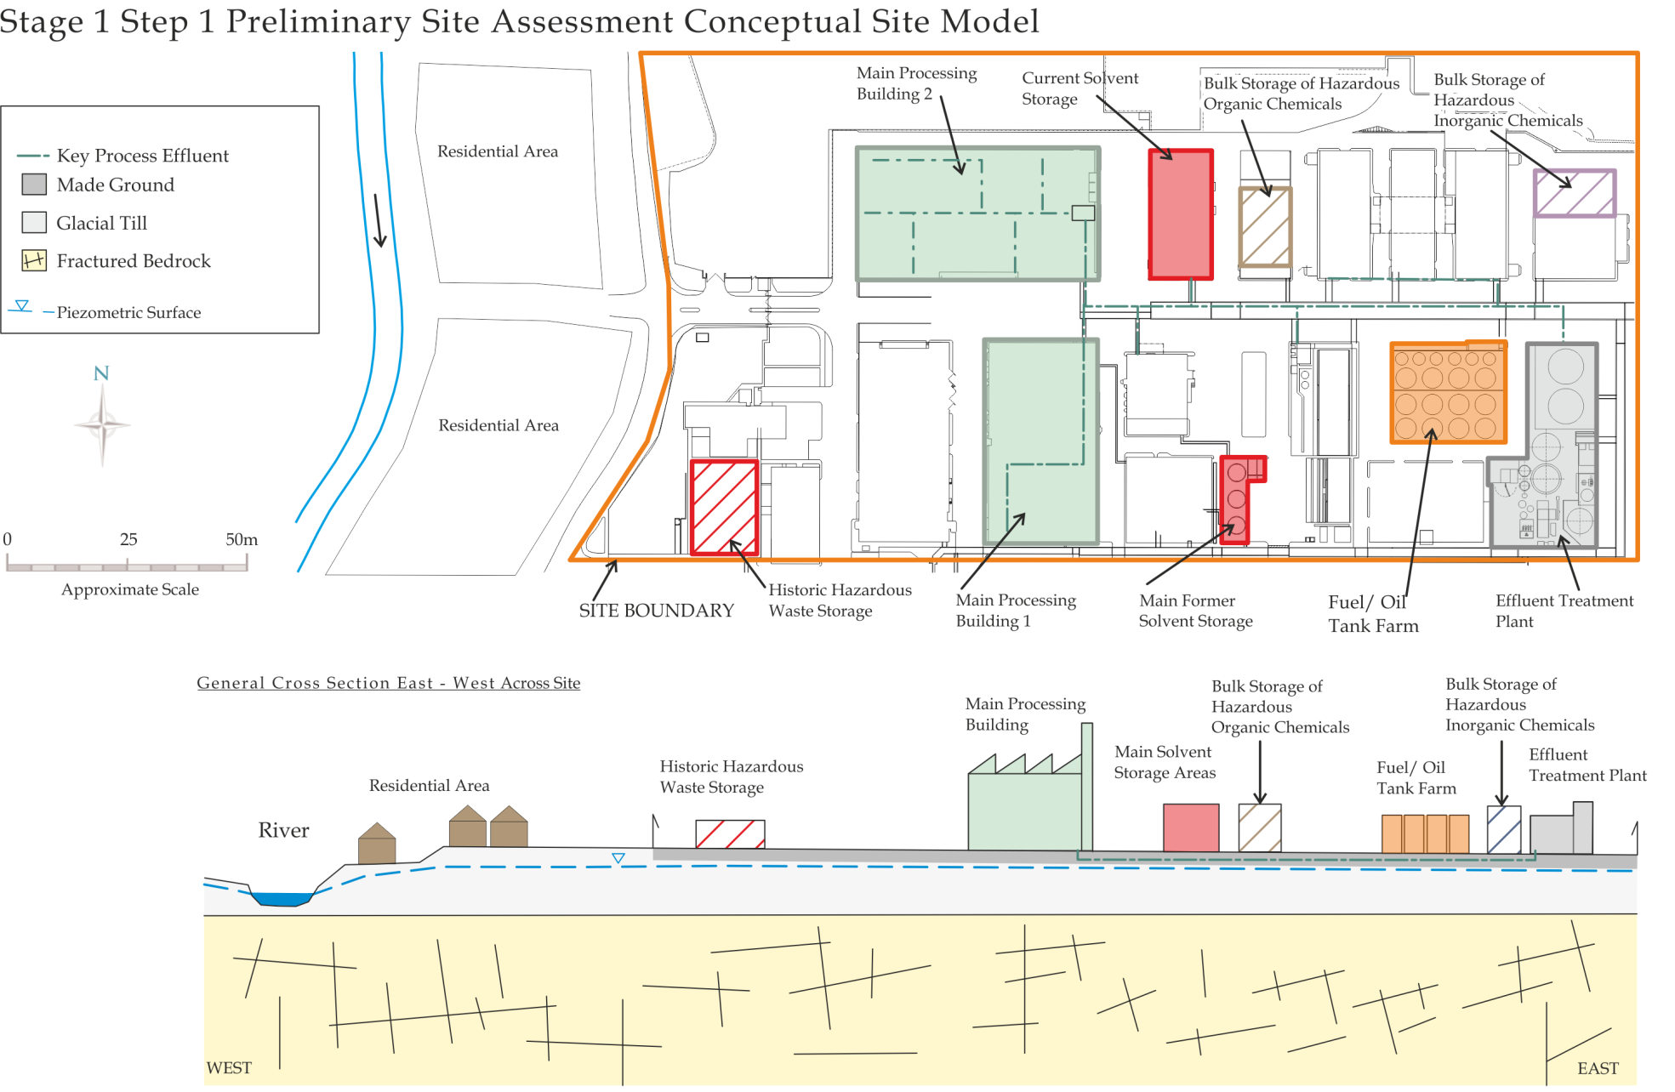
Replace this image with a diagrammatic Conceptual Site Model showing the current understanding of site circumstances.
EPA Contaminated Land & Groundwater Risk Assessment Methodology |  | Report Reference | Report Date | Status
STAGE 1: SITE CHARACTERISATION & ASSESSMENT
1.1 | PRELIMINARY SITE ASSESSMENT | (Insert this report author & reference) | (Insert this report date) | (Draft, Final, etc.)
1.2 | DETAILED SITE ASSESSMENT
1.3 | QUANTITATIVE RISK ASSESSMENT
STAGE 2: CORRECTIVE ACTION FEASIBILITY & DESIGN
2.1 | OUTLINE CORRECTIVE ACTION STRATEGY
2.2 | FEASIBILITY STUDY & OUTLINE DESIGN
2.3 | DETAILED DESIGN
2.4 | FINAL STRATEGY & IMPLEMENTATION PLAN
STAGE 3: CORRECTIVE ACTION IMPLEMENTATION & AFTERCARE
3.1 | ENABLING WORKS
3.2 | CORRECTIVE ACTION IMPLEMENTATION & VERIFICATION
3.3 | AFTERCARE

- introduction
  - PROJECT CONTRACTUAL BASIS AND PERSONNEL INVOLVED
Confirm the contractual basis for the work including the proposal reference number.
List the name and role of the main people who completed the work and their qualifications and years of experience, including the main subcontracted elements if applicable (e.g. sub-consultants; drilling contractor; laboratory analysis).
  - BACKGROUND INFORMATION
This section should succinctly inform the reader what the report is about. It should provide the licensee/site name, its location with reference to a site map and the activity at the site. It should be mentioned that this is a preliminary site assessment including a detailed source audit and desk-based hydrogeological assessment.
Summarise all key background information relevant to the assessment. This should include a summary of previous site work or other information that has previously been provided for the site by the client. For example when the consultant was asked to provide a proposal for the work, the site may have shared some useful information or allowed a site visit to consider the proposed programme of works. The main existing site reports and information that are relevant to the study should be listed and may include RMP (Residual Management Plan), CRAMP (Closure, Restoration, Aftercare & Management Plan) and ELRA (Environmental Liabilities Risk Assessment) documents and groundwater monitoring reports.
  - PROJECT OBJECTIVES
Clearly define the project objectives as established prior to this phase of work commencing.
  - SCOPE OF WORKS
Clearly summarise the scope of works that was developed to meet the defined project objectives and summarise any deviations from the originally planned scope.
- source audit findings – PRODUCTION & OPERATIONAL HISTORY
  - current site operations
This section on current site operations is expected to include information on:
- Hazardous and non-hazardous chemical deliveries, storage and use (may need a particular emphasis on certain chemicals such as select organic solvents). Will need to refer to annual inventory and throughput information for all the main chemicals located on-site (purchasing records, asset registers, etc.) so that the main ones can be identified;
- Hazardous waste generation, storage and disposal, including how it is transferred off-site;
- Understanding of how hazardous raw materials are transferred to production areas and around the site is key (e.g. manifold; underground pipelines) as well as how and where hazardous wastes (liquids or leachable solids) are separated, transferred and stored;
- Product and by-product information when this could be significant in the context of site land and groundwater;
- Infrastructure information in the form of site layouts, testing and monitoring data (for production, storage and transfer areas including drainage and in-ground and below-ground structures in particular);
- Information on the integrity of containment mechanisms, nature and condition of site surfacing, location of drains, services and other potential conduits for migration, e.g. are structures and site surfacing cracked or damaged, are there signs of staining, chemical attack to surfaces, are drains in good condition?
- All emissions to land, groundwater or surface water. Emissions specifically to subsurface infrastructure such as drains and sumps. This must include information on effluent quality (chemical content);
- Mass balance information for key chemicals (i.e. use in product; emissions; waste; recovery);
- Record of reportable environmental incidents/complaints;
- Environmental Management System findings (main environmental aspects linked to land and water).
  - PREVIOUS site operations
This must consider, in as much detail as is needed, the site operational history and changes to the operational footprint over time (from the start).
While this is harder to understand than current operations, it is typically more crucial (so proportionately more time may have to be spent on this element). Should address the above listed aspects (under current operations) but also needs to consider how the building and infrastructure footprint for all chemical/waste storage–transfer–use areas has changed over time (if at all). This should also be captured on one or more site plan figures.
Key information sources and needs are expected to include, but may not be limited to, the following:
- Anecdotal evidence – this can be a very useful component of the information gathering exercise. Staff to consider interviewing should include long servers or past employees, particularly from EHS, production and technical backgrounds. Employees should be encouraged to discuss previous practices, which may not have been acceptable by today’s standards;
- Old site plans, plus old and recent aerial photographs;
- Former production records and information (linked to the main hazardous chemical use information);
- Chemical spill/leak history, accidents, incidents (this may be anecdotal pre-licensing);
- Previous hazardous raw material inventories – purchasing;
- Previous hazardous waste inventories and manifests (it is noted that previous handling and storage of hazardous wastes is particularly important to understand);
- An understanding of the integrity of the site drainage system, tanks, bunds and their development over time. Production area floor drains, sumps and oil/water separators can be the highest risk areas. Understand if there has been a history of damage, upgrade and/or repair to these; maintenance records may assist;
- Understanding of previous direct emissions to land, groundwater or surface water;
- Support services (boiler houses and heating; maintenance shops – in particular the storage and use of degreasing or cleaning chemicals; bulk fuel storage and transfer; bulk heat exchange and refrigeration units);
- Former peripheral areas of the site where ad hoc or temporary storage (disposal) may have taken place, particularly in the past.
  - cHEMICALS OF POTENTIAL CONCERN
This section must provide detail of all identified Chemicals/Contaminants of Potential Concern (COPC) based on the understanding of current and historical use of hazardous chemical and related substances at the site.
A list of COPCs must be provided with a summary statement on why they have been selected from an operational or other point of view. This may be expected to include but not be limited to volumes stored and/or throughput, how they have been stored and transferred, the amount of hazardous waste and/or effluent associated with them, and their specific chemical toxicity and mobility in soil and groundwater systems.
It is also very important to provide justification for excluding chemicals from the COPC list, if this has been done, particularly if they have been used or stored in relatively large volumes.
The best way to summarise these findings is in a table or series of tables.
- SITE ENVIRONMENTAL SETTING
  - GENERAL INTRODUCTION
This should describe the overall site setting as evidenced from local Ordnance Survey maps and information and based on a reconnaissance of the site and its surrounding area as part of the source audit site visit. Of particular importance are expected to be:
- A description of the site location and topographic setting of the site
- Local land use and potential off-site sources of contamination
- Presence of residential properties and communities
- Location of surface water features including service channels, land drains, outfalls; the direction of flow, quality and classification
- Possible local groundwater (water) users (e.g. old houses; presence of header tanks).
  - REGIONAL GEOLOGY AND HYDROGEOLOGY
This section will be based on published maps and memoirs that are readily available (e.g. Geological Survey of Ireland (GSI), EPA, Teagasc). The introduction of the Water Framework Directive (WFD) in late 2000 acted as a catalyst for the acquisition and processing of new data, and creation of new datasets, in order to satisfy the needs of the directive and daughter directives.
In general, it is expected that the regional geology and regional hydrogeology information will be presented in two separate subsections.
Key data sources that are expected to support this section are:
- Bedrock geology maps; in addition to the stratigraphy and lithologies present in the area, where relevant this section should include material on the geological structure and references to fracture/joint patterns and faulting
- Bedrock and sand/gravel aquifer maps
- Interim groundwater vulnerability maps (County maps becoming available)
- Subsoil and soil maps, including soil permeability maps
- Groundwater recharge maps
- Groundwater Body (GWB) maps and reports; water body maps and reports
- Article 5 Risk Assessments for GWBs (and other waters)
- Draft River Basin Management Plans (RBMP) (2008)
- Groundwater-dependent terrestrial ecosystems
- Groundwater monitoring network quality and water level database.
In addition, there are a number of widely available reports on the geology and hydrogeology of Ireland as well as relevant scientific literature from which useful material can be obtained.
The section on the hydrogeology should include, after delineation of groundwater bodies and aquifer/aquitard units, a description of the type of permeability of the principal formations of interest, the hydraulic conditions, water table conditions, general hydrochemistry and water quality if known and aquifer vulnerability in addition to the aspects mentioned in the list of maps. The order should be roughly as outlined so that the reader can be formulating an initial conceptual model in their mind.
Details of any high-yielding wells in the area and their likely source protection zones, whether delineated or not, should also be included.
Aspects of the hydrology of the site should be described on a regional basis, especially if the site is large. Details of rainfall, potential and actual evapotranspiration and effective rainfall and their typical variations throughout the year should be provided.
  - SITE GEOLOGY AND HYDROGEOLOGY
This section will be based on information gained during the site visit (recognising that in many cases no new intrusive investigations will be carried out as part of this preliminary site assessment). Information sources to gain a better understanding of site-specific geology and hydrogeology are expected to include:
- Reconnaissance of the site and the local area during the site visit (audit)
- Presence of bedrock outcrops in the vicinity of the site
- Presence of surface waters on or close to the site
- Site geotechnical investigation reports (can be held by engineering department)
- Site environmental due diligence reports if the site has changed ownership in the past (site management or EHS department may have these)
- Other site investigation or monitoring reports for whatever purpose
- Well records and borehole logs for on-site abstraction well(s).
Other information sources that could be consulted include historic 6” Ordnance Survey maps, the original Geological Survey manuscript field slips (6” scale), the Teagasc series of County Maps, material in local authority files (e.g. EISs) and relevant scientific literature.
Information may include detailed descriptions of the geology encountered, including GWB units if penetrated, soil and aquifer property information (e.g. grain size, organic carbon content, hydraulic, permeability or well test data) and groundwater flow direction.
  - SUMMARY OF PREVIOUS SITE SAMPLING AND MONITORING DATA
There may be site investigation and/or monitoring data (for groundwater and soil) that may give clues to past issues or impacts. These are the same reports as indicated above in Section 3.3. There may also be groundwater quality data for on-site abstraction wells. The purpose of looking at this data and information, if it exists, is to try to focus the COPC list by scrutinising actual monitoring data. However, it will be important to judge openly the quality and relevance of such data to avoid misuse or over-interpretation. A clear statement must be made with respect to all such reports and data sources.
Some of the main information that may help to refine the COPC list (if it is suitably sourced and robust) would be expected to include:
- Soil quality data close to potential source areas (and the site generally)

- Shallow or perched groundwater data close to potential source areas (and the site generally)
- Soil vapour data close to potential VOC source areas (and for the site generally)
- Deeper groundwater quality data close to or down-gradient of key areas (up-gradient also useful if site is within a non-greenfield area)
- Abstraction well water quality data, recognising the level of dilution of shallow contamination that this may entail (need to understand abstraction regime, well depth, etc.).
If there is good monitoring (chemical) data for key source areas or the COPCs already identified for the site then this should allow some level of refinement of the shortlist of COPCs. This may include justification for removal of some of the previously identified COPCs and/or the addition of other COPCs to the list due to their identified presence in soil and/or groundwater at the site. If COPCs are to be added due to their reported presence in soil and/or groundwater then it will be necessary to revisit the source audit process to enquire as to their potential use on-site (why they are there – could they relate to off-site sources, etc.?).
- SUMMARY, CONCLUSIONS AND RECOMMENDATIONS
  - SUMMARY AND CONCLUSIONS
This section must bring together all the above findings in a concise and clear way so that the reader is able to understand where all the main potential source areas of soil and/or groundwater contamination are located on the site and what the environmental site setting and sensitivities are. Annotated, scaled, site plans should be used to present key source areas, with local area plans used as needed to provide sufficient specific detail. If there are a lot of COPCs then a number of such plans can be expected to be needed. Core figures may be expected to include:
- Site Plan showing all the main current chemical and waste storage areas, fixed transfer routes and production (use) areas, and the production effluent drainage network
- Site Plan showing all the main former chemical storage areas, fixed transfer routes and production (use) areas, if these were different
- Site plan(s) showing by COPC or COPC group the main areas of potential concern
- A more regional plan showing a summary of the main environmental setting and sensitivity information for the site area.
In most cases it will be expected that a preliminary Conceptual Site Model (CSM) will be presented, including text but also in diagrammatic form. The latter may be two-dimensional (potentially requiring plan and cross-sectional views) or three-dimensional.
At this stage (Preliminary Site Assessment) it may be expected that this will be the first CSM generated for the site, but if this is not the case then the changes to the previous version and the basis for these must be summarised here.
  - RECOMMENDED WAY FORWARD
This section must include a summary of what are considered to be the main data gaps that may limit understanding, and the recommended way these are to be addressed.
The final element of the section must provide some detail on the scope of proposed intrusive investigations that are expected to be necessary to understand the potential chemical character, magnitude and extent of soil- and groundwater-related contamination at the site.
An outline of the following should be included:
- A figure showing provisional investigation locations
- An outline of the samples that may be collected and the tests that might be conducted on them
- An outline of in-situ tests that may be completed to assess site hydrogeology.
- references
A list of references and sources of information used in the report should be included in this section.

oo0oo
Respectfully submitted
On behalf of Consultant Name

Sign Here

(Project Manager/Project Director/Lead Consultant)

Hunter-Williams et al. (Presentation to the International Association of Hydrogeologists (Irish Group) Conference, Tullamore, 2009)

