LICENCE REFERENCE No. | RISK ASSESSMENT METHODOLOGY STAGE & STEP |  | REPORT VERSION
Insert licence reference number | Insert methodology stage and step, e.g. Stage 1 Step 3 |  | Insert report version no., e.g. Draft, Final
INSERT COMPANY LOGO/HEADER
Guideline Template for Quantitative Risk Assessment Report
for the Environmental Protection Agency
(Month Year)
(LICENCE No.)

INSTRUCTIONS on use of this template
                - This document presents a guideline reporting template for stakeholders to use when reporting a Quantitative Risk Assessment under the EPA Contaminated Land & Groundwater Risk Assessment Methodology. It is designed to assist stakeholders with the submission of the correct information in a suitable format to the EPA. It should be regarded as a comprehensive guide; it is not intended to be a wholly prescriptive template.
                - Where there are deficiencies or uncertainties in the information provided these should be clearly marked and annotated to indicate where further data gathering may be required.
                - In the template, those parts written in red indicate where relevant information and/or assessment should be entered. In entering this information the red text should be deleted or written over and the text reformatted to normal style.
                - For a glossary of terms and acronyms used in this template report and for a list of key technical guidance documents, refer to the ‘Guidance on the Management of Contaminated Land and Groundwater at EPA Licensed Sites’ (EPA, 2013).
                - Delete this page before submitting this report to the EPA.

Project Title: |  | Quantitative Risk Assessment Report
Licence No: |  | (complete)
Project No: |  | (complete)
Contract No: |  | (complete)
Report Ref: |  | (complete)
Status: |  | (Draft/2nd Draft/Final (examples))
Client: |  | (complete)
Client Details: |  | (complete)
Issued By: |  | (Consultancy company name and address)
Document Production/Approval Record
 | Name |  | Signature | Date | Position | % Input
Prepared by (consultant) | Insert here |  | Insert here | Insert here | Insert here | Insert here
Approved by (consultant) | Insert here |  | Insert here | Insert here | Insert here | Insert here
Site Approval by | Insert here |  | Insert here | Insert here | Insert here | N/A
Limitation
                - All limitations that apply to the work should be summarised here, including reference to the original proposal for the work and the originally proposed project objectives and scope of works. State if these were achieved and the scope of works completed. Where the scope deviated significantly from the originally proposed scope, this should be summarised herein (if a limitation). State the limit of liability, reliance, etc. that apply to this project.

                - TABLE OF contents
Section |  | Page No
executive summary i
1. introduction 1
1.1. PROJECT CONTRACTUAL BASIS & Parties INVOLVED 1
1.2. BACKGROUND INFORMATION 1
1.3. PROJECT OBJECTIVES 1
1.4. SCOPE OF WORKS 1
2. generic quantitative risk assessment 1
2.1. potential pollutant linkages 2
2.2. generic assessment criteria 2
2.3. Source zone contaminant data management 2
2.4. Results of generic quantitative risk assessment 2
3. detailed quantitative risk assessment 3
3.1. potential pollutant linkages 3
3.2. risk estimation model/tool development for DQRA 3
3.2.1. contaminant sources 3
3.2.2. migration/exposure pathways 3
3.2.3. potential receptors 4
3.2.4. quantitative model development, sensitivity analysis & calibration 4
3.3. Detailed Risk evaluation 4
3.3.1. source zone data management 4
3.3.2. results of detailed quantitive risk assessment 5
4. SUMMARY, CONCLUSIONS AND RECOMMENDATIONS 5
4.1. SUMMARY AND CONCLUSIONS 5
4.2. RECOMMENDED WAY FORWARD 5
                - Update table of contents once all relevant report sections have been completed.
figures (to be expected)
Figure 1 | Site location plan
Figure 2 | Site layout plan showing main buildings and infrastructure
Figure 3+ | Site investigation sampling location plans
Figure 4+ | Hydrogeological regime plans
Figure 5+ | Site plans illustrating the locations and salient features of contaminant source zones, pathways and receptors
Figure 6 | Technical illustration presenting the updated conceptual site model (CSM) post quantitative risk assessment; in all cases the CSM should be illustrated in diagrammatic form.
Tables (to be expected)
Tables(s) | Depending on the task, tables presenting:  - Supporting field and/or laboratory data  - Generic and/or site-specific assessment criteria used for risk assessment  - Summary tables of source zone contaminant dataset screening (if used)  - Any other information pertinent to the risk assessment process
appendices (that may be expected to be useful)
Appendix A+ | Appended information that may include:  - Geological cross-sections and/or key borehole/monitoring well logs  - Supporting field and/or laboratory data (if not tabulated or referenced elsewhere) such as results of hydraulic conductivity testing, fraction of organic carbon, hydrographs, etc.  - Groundwater and/or land gas monitoring data if detail is considered useful to include and has not been explicitly summarised elsewhere  - Details of statistical data analysis (if used)  - Details of risk estimation model parameter inputs (for GQRA and/or DQRA) (if used)  - Model outputs for DQRA (if used)

executive summary
An Executive Summary is considered necessary for all reports of any size to allow a reader to quickly understand project objectives and scope of work and all the main findings.
This must include, as a separate page within the executive summary, the latest diagrammatic Conceptual Site Model (CSM) based on data collected during this phase of the site programme of works (see attached example).
It must also include a flow chart illustrating where this report sits in the overall contaminated land and groundwater site assessment and corrective action process, confirming all aspects already completed (see attached example).

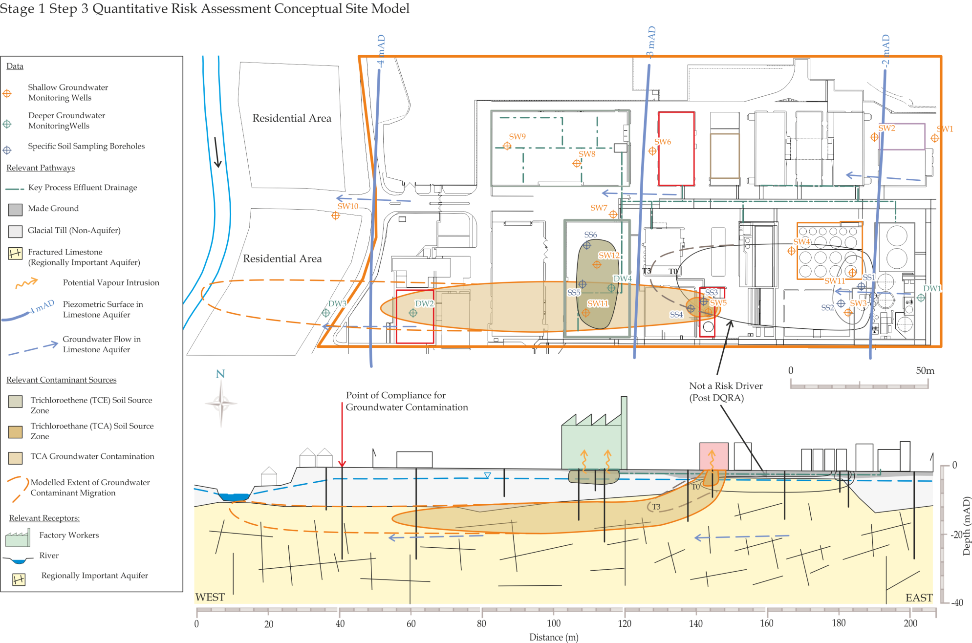
Replace this image with a diagrammatic Conceptual Site Model showing the current understanding of site circumstances.
EPA Contaminated Land & Groundwater Risk Assessment Methodology |  | Report Reference | Report Date | Status
STAGE 1: SITE CHARACTERISATION & ASSESSMENT
1.1 | PRELIMINARY SITE ASSESSMENT | (Insert previous report author & reference) | (Insert previous report date) | (Should be Final)
1.2 | DETAILED SITE ASSESSMENT | (Insert previous report author & reference) | (Insert previous report date) | (Should be Final)
1.3 | QUANTITATIVE RISK ASSESSMENT | (Insert this report author & reference) | (Insert this report date) | (Draft, Final, etc.)
STAGE 2: CORRECTIVE ACTION FEASIBILITY & DESIGN
2.1 | OUTLINE CORRECTIVE ACTION STRATEGY
2.2 | FEASIBILITY STUDY & OUTLINE DESIGN
2.3 | DETAILED DESIGN
2.4 | FINAL STRATEGY & IMPLEMENTATION PLAN
STAGE 3: CORRECTIVE ACTION IMPLEMENTATION & AFTERCARE
3.1 | ENABLING WORKS
3.2 | CORRECTIVE ACTION IMPLEMENTATION & VERIFICATION
3.3 | AFTERCARE

- introduction
  - PROJECT CONTRACTUAL BASIS & Parties INVOLVED
Confirm the contractual basis for the work including the proposal reference number.
List the name and role of the main people who completed the work and their qualifications and years of experience, including the main subcontracted elements, if applicable (e.g. sub-consultants).
  - BACKGROUND INFORMATION
This section should succinctly inform the reader what the report is about. It should provide the licensee/site name, its location with reference to a site map and the activity at the site.
Summarise background information relevant to the risk assessment, such as the main findings of works completed in Stages 1.1 Preliminary Site Assessment and 1.2 Detailed Site Assessment.
Detail relevant information from the Stage 1.2 Conceptual Site Model (CSM), specifically:
- Potential pollutant linkages (source–pathway–receptor relationships) to be assessed by this report;
- Existing understanding of site history/operations/layout, geology, hydrogeology and geochemistry, and potential influences on land and groundwater contamination and associated potential risks pertinent to the identified pollutant linkages.
Tabulate and/or append relevant information (Table xx/Appendix xx, e.g. exploratory hole logs, geological cross-sections, groundwater/land gas monitoring data, etc.) or, if presented elsewhere in previously submitted and readily available reports, clearly reference the data used (including report title, author, date, reference, figure/table/appendix number and page).
It is often best to make the Quantitative Risk Assessment report as standalone as possible by including all key, relevant data and information (rather than referring to data contained within other reports).
  - PROJECT OBJECTIVES
Clearly define the project objectives as established prior to this phase of work commencing.
  - SCOPE OF WORKS
Clearly summarise the scope of works that was developed to meet the defined report objectives and deviations from the originally planned scope, if any. Specifically:
- Describe and justify the selection of the risk assessment methodologies and models adopted for each pollutant linkage, with reference to the Stage 1.2 Conceptual Site Model;
- Broadly explain how these methodologies and models were implemented.
- generic quantitative risk assessment
(GQRA may have already been done at the Stage 1.2 Detailed Site Assessment; if so just summarise the previous findings under here.)

  - potential pollutant linkages
Clearly state which Contaminants of Potential Concern (COPC) and pollutant linkages are being assessed by the Generic Quantitative Risk Assessment (GQRA) and why they have been selected (and others not), with reference to the CSM.
It may be necessary to perform several GQRAs if multiple receptors have been identified, e.g. human health GQRA, groundwater GQRA. If this is the case, for clarity, describe the GQRA for each type of receptor in separate sections.
  - generic assessment criteria
Justify the selection of generic assessment criteria (GAC) for each receptor type with reference to the CSM and reference their sources. For example, interim groundwater values (IGVs) and groundwater threshold values (GTVs) represent such criteria for groundwater in Ireland.
If used, summarise the derivation of in-house GAC using risk assessment tools/models. Reference and justify sources of model parameter data with respect to the CSM. Identify and comment on any limitations with respect to the application of GAC to this risk assessment.
Tabulate and refer to summaries of all GAC used in this report (Table XX).
Clearly state if GAC and therefore GQRA are not appropriate to the risk assessment for some or all COPC and pollutant linkages. If this is the case, state what action is to be taken with respect to these potential pollutant linkages, for example perform detailed quantitative risk assessment (see Section 3) or begin the Stage 2 corrective action process (see Section 4.2).
  - Source zone contaminant data management
Clearly describe how the contaminant datasets were managed to facilitate comparison with generic assessment criteria. Use the CSM to justify your decisions.
This could include:
- How and why contaminant data were segregated, for example by soil type, depth, groundwater unit, receptor, site zoning;
- The application of statistical methods;
- Any calculations/modelling undertaken to facilitate generic quantitative risk assessment; for example, soil source partitioning to pore water calculation;
- Any assumptions and/or limitations with respect to the above.
Tabulate/append relevant source data (Table XX/Appendix XX, e.g. laboratory sample data, groundwater/gas monitoring records, statistics, calculations, etc.) or, if presented elsewhere in previously submitted and readily available reports, clearly reference the data used (including report title, author, date, reference, figure/table/appendix number and page).
It is usually best to make the Quantitative Risk Assessment report as standalone as possible by including all key, relevant data and information from previous phases of work.
  - Results of generic quantitative risk assessment
Describe how the GAC were applied and the results of GQRA. For example list the nature, magnitude and distribution of contaminants for which generic risk assessment confirms there to be a potential pollutant linkage. Tabulate a summary of the results of the GQRA screening and evaluate the risk of the potential pollutant linkages.
Draw conclusions with respect to the potential pollutant linkages under assessment. Justify these conclusions with regard to the CSM, limitations and assumptions made in the GQRA process. Use technical diagrams to illustrate these conclusions (usually beneficial).
State what action is to be taken with respect to relevant potential pollutant linkages: for example, a requirement for detailed quantitative risk assessment, further data collection, corrective action, or perhaps there being no action required as there appear to be no identified potential risk, etc.
- detailed quantitative risk assessment
  - potential pollutant linkages
Clearly state which COPC and pollutant linkages need to be assessed using detailed quantitative risk assessment (DQRA) and why. Refer to the results of GQRA (if used) and/or the CSM.
The DQRA may have a number of elements, if multiple receptors are identified (e.g. human health DQRA; groundwater DQRA). If required, clearly describe the DQRA for each type of receptor in separate sections.
  - risk estimation model/tool development for DQRA
    - contaminant sources
This section should include contaminant source information pertinent to detailed risk assessment (based on the CSM). This should include:
- The nature, magnitude, location and geometry of contaminant sources (COPC);
- How the sources are to be represented quantitatively within a risk assessment model/tool;
- Any underlying assumptions and/or limitations with respect to the above.
Tabulate or append (Table xx/Appendix xx) source zone input parameters showing justification for their selection. Consider using technical diagrams to illustrate the above (usually beneficial).
    - migration/exposure pathways
This section should provide information on:
- Physical pathway characteristics; for example, pathway length/width, hydraulic gradient, hydraulic conductivity, porosity, building dimensions;
- Physical attenuation mechanisms (if relevant); for example, dilution, adsorption and dispersion;
- Bio-geochemical attenuation mechanisms (if relevant); for example, absorption and degradation;
- How the above are to be represented quantitatively within a risk assessment model with any underlying assumptions and limitations noted.
Tabulate or append (Table XX/Appendix XX) migration/exposure pathway input parameters showing justification for their selection. Consider using technical diagrams to illustrate the above (usually beneficial).

    - potential receptors
Clearly define the potential receptor and any associated assumptions. For example, a female working adult aged 16–65 exposed during working hours, a braided river channel supporting salmonid habitats, or an offsite drinking water supply well.
Indicate how the receptor is to be represented quantitatively within the model.
With regard to hydrogeological risk assessment, the receptor will be represented by the Compliance Regime. Use this to designate target concentrations and the compliance point. Provide justification for these selections with reference to the Stage 1.2 Detailed Site assessment CSM.
Tabulate or append (Table xx/Appendix xx) potential receptor input parameters showing justification for their selection. Use technical diagrams to illustrate the above (usually beneficial).
    - quantitative model development, sensitivity analysis & calibration
State how the CSM of pollutant linkages was represented and implemented in a quantitative model/software.
Describe the performance and findings of sensitivity analysis and model calibration. Detail the final model input parameters.
Describe the model output and how this was developed to facilitate DQRA. For example, detailed quantitative modelling used to predict contaminant concentrations at the receptor and back-calculate site-specific assessment criteria (SSAC) for comparison with source area contaminant data.
Provide summary tables (Table xx, list of COPC concentration and breakthrough time at point of compliance, SSAC, etc.). Append the model output (Appendix xx, summary results sheets, etc. from model).
  - Detailed Risk evaluation
    - source zone data management
If comparing SSAC with source zone data, clearly describe how the contaminant datasets were managed to facilitate this (may be able to simply refer to section 2.3 if described therein). Use the CSM to justify your decisions.
This could include:
- How and why contaminant data were segregated, for example by soil type, depth, groundwater unit, receptor, site zoning;
- The application of statistical methods;
- Any calculations/modelling undertaken to facilitate generic quantitative risk assessment, for example, soil source partitioning to pore water calculation;
- Any assumptions and/or limitations with respect to the above.
Append relevant source data (Appendix xx, e.g. laboratory sample data, groundwater/gas monitoring records, statistics, calculations, etc.) or, if presented elsewhere in previously submitted and readily available reports, clearly reference the data used (including figure/table/appendix number and page).

    - results of detailed quantitive risk assessment
Describe the results of the detailed quantitative modelling and the comparison of SSAC with source data (if used). Verify the findings using the CSM, limitations and assumptions made in the DQRA process.
Draw conclusions with respect to the potential pollutant linkages under assessment. Tabulate a summary of the results of DQRA and evaluate the risk for each potential pollution linkage. Use technical diagrams to illustrate these conclusions (usually beneficial).
State what action is to be taken with respect to relevant potential pollutant linkages. For example, further data collection to undertake more detailed quantitative risk assessment, begin corrective action process (move to Stage 2), or possibly conclude that no action is required as no identified potential risk has been computed (and none suspected).
- SUMMARY, CONCLUSIONS AND RECOMMENDATIONS
  - SUMMARY AND CONCLUSIONS
This section must bring together all the above findings in a concise and clear way so that the reader is able to understand which potential pollutant linkages were evaluated by generic and/or detailed quantitative risk assessment, what the outcome of these current assessments was and what decisions have been made with respect to these potential pollutant linkages.
Present an updated CSM of pollutant linkages here and use technical diagrams to illustrate this. A typical cross-section through the site is expected in all cases; however, well-constructed matrices or network diagrams may also be used. The text should clearly state what if any site-specific drivers remain and, if so, which pollutant linkages they relate to. It should also highlight data gaps and key assumptions made that can be expected to influence the proposed way forward.
  - RECOMMENDED WAY FORWARD
Where potential risks (or key data gaps) have been identified, further action will be required, such as data collection to facilitate more detailed quantitative risk assessment or corrective action.
This section must include a summary of what action is to be taken and outline the objectives of this next phase of assessment. Provide some detail on the scope of further work, which may include:
- Additional investigations to better understand the nature, magnitude and extent of relevant source zones and/or pathway and/or receptor characteristics (including the locations of proposed investigative sampling).
- Outline proposal for ongoing groundwater/gas monitoring to confirm the findings of GQRA/DQRA (or otherwise) including the monitoring locations, frequency, COPC and other parameters to be determined, etc.
- Development of an outline corrective action strategy which can be started herein and completed as part of Stage 2, Step 1 (the results of GQRA/DQRA should inform objective setting for Corrective Action).
If the DQRA has identified only an apparently marginal risk then an initial monitoring-based strategy may be appropriate to generate an improved dataset, allowing more robust decision making.

oo00oo

Respectfully submitted
On behalf of Consultant Name

Sign Here

(Project Manager/Project Director/Lead Consultant)

