LICENCE REFERENCE No. | RISK ASSESSMENT METHODOLOGY STAGE & STEP |  | REPORT VERSION
Insert licence reference number | Insert methodology stage and step, e.g. Stage 3 Step 1 |  | Insert report version no., e.g. Draft, Final
INSERT COMPANY LOGO/HEADER
Guideline Template for Construction Phase/Enabling Works Report
for the Environmental Protection Agency
(Month Year)
(LICENCE No.)

INSTRUCTIONS on use of this template
                - This document presents a guideline reporting template for stakeholders to use when reporting Corrective Action Enabling Works under the EPA Contaminated Land & Groundwater Risk Assessment Methodology. It is designed to assist stakeholders with the submission of the correct information in a suitable format to the EPA. It should be regarded as a comprehensive guide; it is not intended as a wholly prescriptive template.
                - Where there are deficiencies or uncertainties in the information provided these should be clearly marked and annotated to indicate where further data gathering may be required.
                - In the template, those parts written in red indicate where relevant information and/or assessment should be entered. In entering this information the red text should be deleted or written over and the text reformatted to normal style.
                - For a glossary of terms and acronyms used in this template report and for a list of key technical guidance, refer to the ‘Guidance on the Management of Contaminated Land and Groundwater at EPA Licensed Sites’ (EPA, 2013).
                - Delete this page before submitting this report to the EPA.

Project Title: |  | Construction Phase/Enabling Works Report
Licence No:  Project No: |  | (complete)  (complete)
Contract No: |  | (complete)
Report Ref: |  | (complete)
Status: |  | (Draft/2nd Draft/Final (examples))
Client: |  | (complete)
Client Details: |  | (complete)
Issued By: |  | (Consultancy company name and address)
Document Production/Approval Record
 | Name |  | Signature | Date | Position | % Input
Prepared by (consultant) | Insert here |  | Insert here | Insert here | Insert here | Insert here
Approved by (consultant) | Insert here |  | Insert here | Insert here | Insert here | Insert here
Site Approval by | Insert here |  | Insert here | Insert here | Insert here | N/A
Limitation
                - All limitations that apply to the work should be summarised here, including reference to the original proposal for the work and the originally proposed project objectives and scope of works. State if these were achieved and the scope of works completed. Where the scope deviated significantly from the originally proposed scope, this should be summarised herein (if a limitation). State the limit of liability, reliance, etc. that apply to this project.

                - TABLE OF contents
Section |  | Page No
executive summary i
1. introduction 1
1.1. PROJECT CONTRACTUAL BASIS AND PERSONNEL INVOLVED 1
1.2. BACKGROUND INFORMATION 1
1.3. PROJECT OBJECTIVES 1
1.4. OUTLINE SCOPE OF WORKS 1
2. DETAILs of construction/enabling works 1
3. testing & commissioning 2
4. summary & CONCLUSIONS 2
                - Update table of contents once all relevant report sections have been completed.
figures (to be expected)
Figure 1 | Site location plan
Figure 2+ | Site layout plan showing main buildings and infrastructure, and the areas where the Construction Works/Enabling Works took place
Figure 3+ | Smaller scale site plan(s) – if necessary, that show in more detail the areas where Construction Works/Enabling Works took place
Figure 4+ | Environmental monitoring points
appendices (that may be expected to be useful)
The contents of the Appendices will be project-specific; however, the following may be relevant.
Appendix A | As-built drawings that clearly show the work completed
Appendix B | Materials test results (to include those specified in the Final Strategy & Implementation Plan), including QA certificates from suppliers
Appendix C | Waste transfer documentation
Appendix D | Licences & permits
Appendix E | Inspection records
Appendix F | Photographic record
Appendix G | Environmental/H&S monitoring results
Appendix H | Baseline monitoring results
Appendix I | Operating manuals
Appendix J | Maintenance programme

executive summary
An Executive Summary is considered necessary for all reports of any size to allow a reader to quickly understand project objectives and scope of work and all the main findings.
This must include, as a separate page within the executive summary, the latest diagrammatic Conceptual Site Model (CSM) based on data collected during this phase of the site programme of works (see attached example) and illustrating the methodologies by which the proposed corrective action programme will address the remedial objectives.
It must also include a flow chart illustrating where this report sits in the overall contaminated land and groundwater site assessment and corrective action process, confirming all aspects already completed (see attached example).

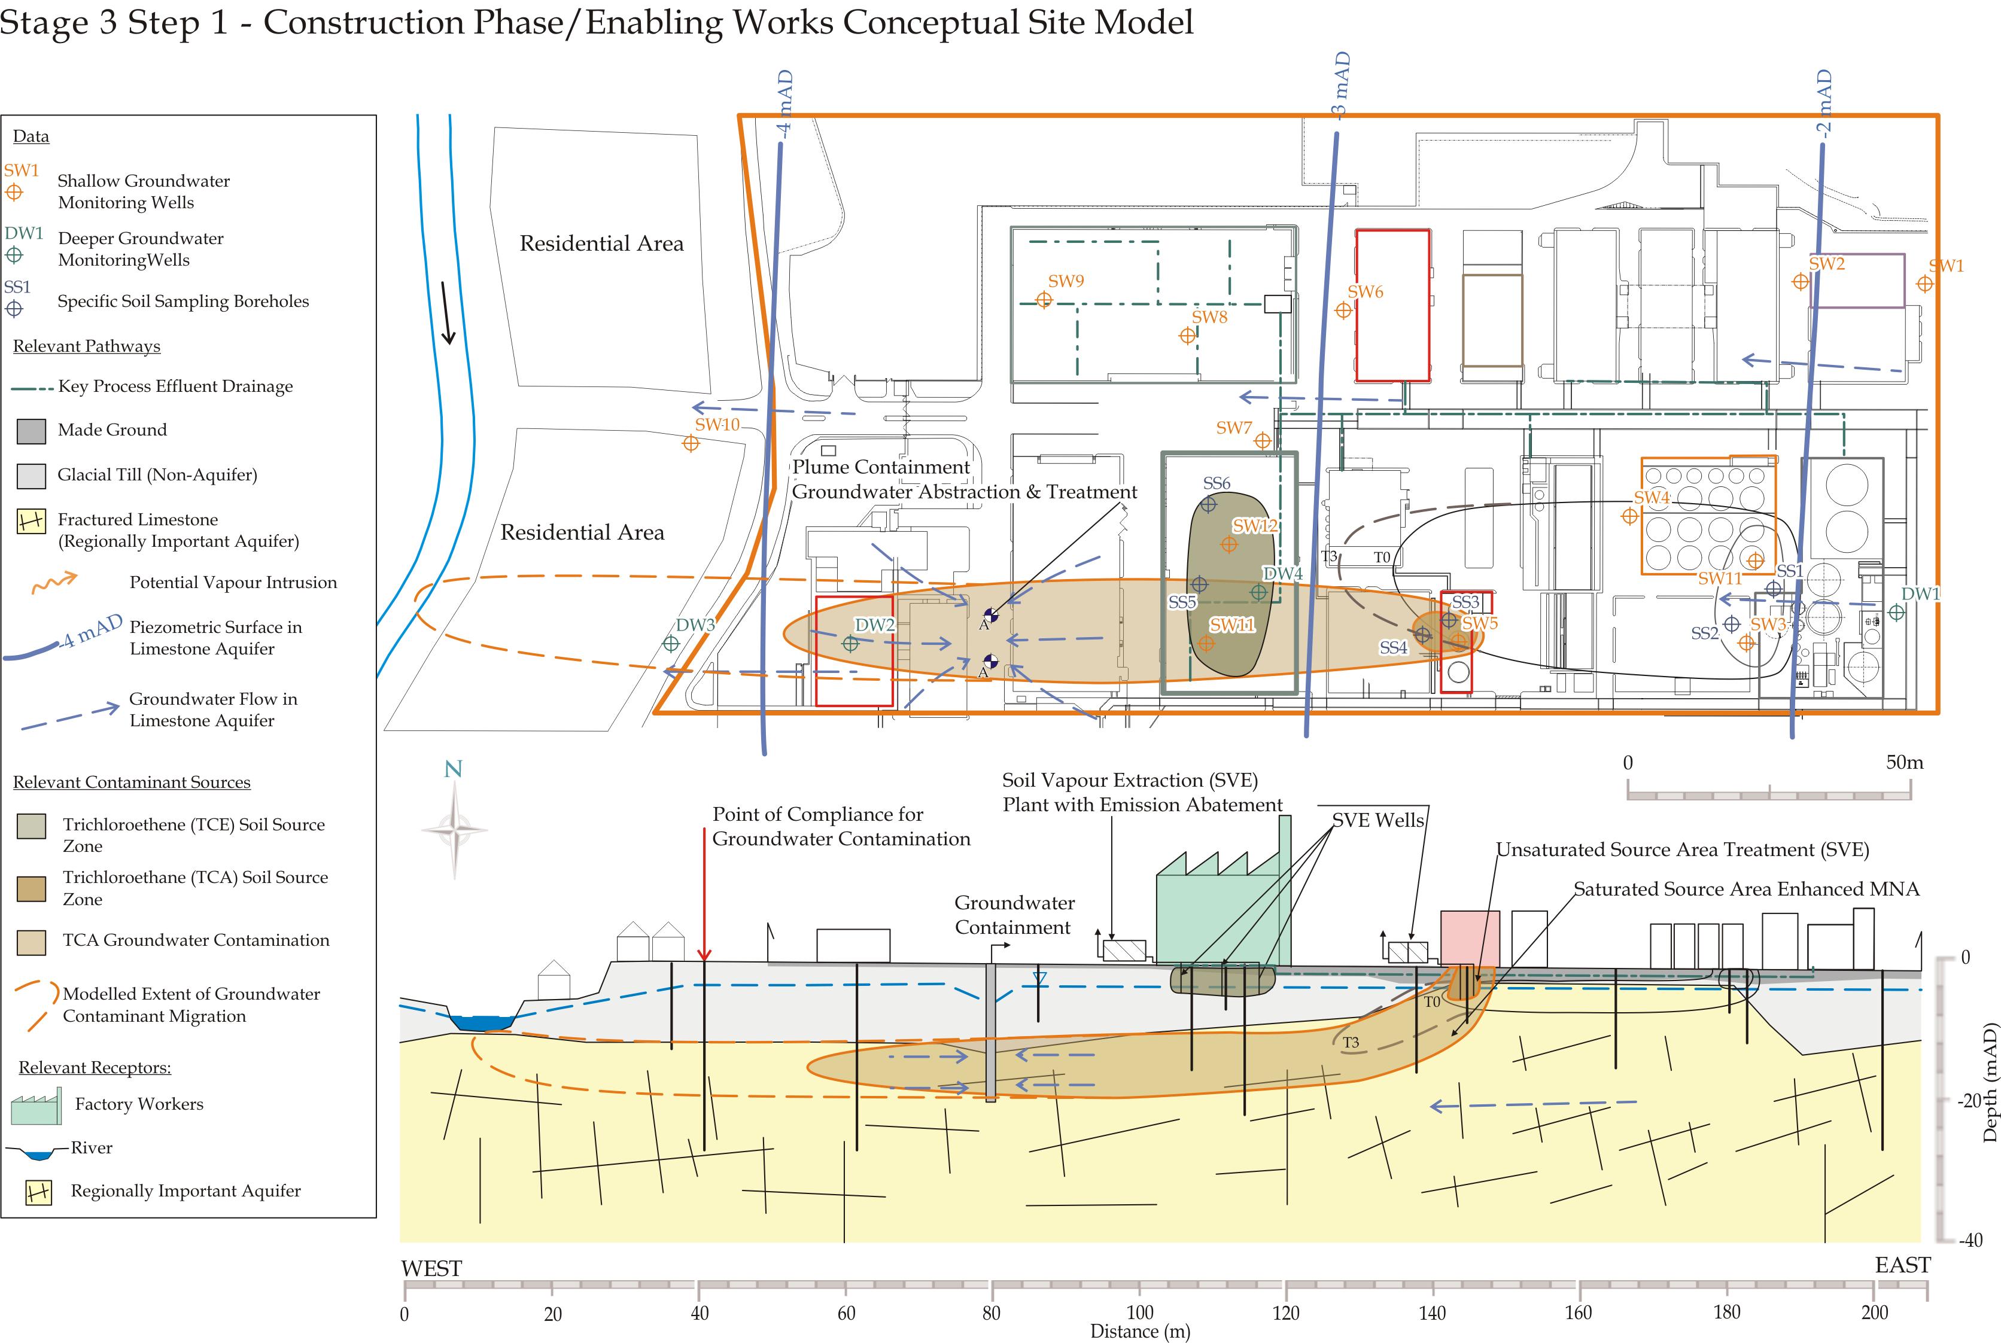
Replace this image with a diagrammatic Conceptual Site Model showing the current understanding of site circumstances.
EPA Contaminated Land & Groundwater Risk Assessment Methodology |  | Report Reference | Report Date | Status
STAGE 1: SITE CHARACTERISATION & ASSESSMENT
1.1 | PRELIMINARY SITE ASSESSMENT | (Insert previous report author & reference) | (Insert previous report date) | (Should be Final)
1.2 | DETAILED SITE ASSESSMENT | (Insert previous report author & reference) | (Insert previous report date) | (Should be Final)
1.3 | QUANTITATIVE RISK ASSESSMENT | (Insert previous report author & reference) | (Insert previous report date) | (Should be Final)
STAGE 2: CORRECTIVE ACTION FEASIBILITY & DESIGN
2.1 | OUTLINE CORRECTIVE ACTION STRATEGY | (Insert previous report author & reference) | (Insert previous report date) | (Should be Final)
2.2 | FEASIBILITY STUDY & OUTLINE DESIGN | (Insert previous report author & reference) | (Insert previous report date) | (Should be Final)
2.3 | DETAILED DESIGN | (Insert previous report author & reference) | (Insert previous report date) | (Should be Final)
2.4 | FINAL STRATEGY & IMPLEMENTATION PLAN | (Insert previous report author & reference) | (Insert previous report date) | (Should be Final)
STAGE 3: CORRECTIVE ACTION IMPLEMENTATION & AFTERCARE
3.1 | ENABLING WORKS | (Insert this report author & reference) | (Insert this report date) | (Draft, Final, etc.)
3.2 | CORRECTIVE ACTION IMPLEMENTATION & VERIFICATION
3.3 | AFTERCARE

- introduction
  - PROJECT CONTRACTUAL BASIS AND PERSONNEL INVOLVED
Confirm the contractual basis for the work including the proposal reference number.
List the name and role of the main people and parties who completed the work and their qualifications and years of experience, including the main subcontracted elements (i.e. subconsultants; contractors and their respective roles).
In particular, state who was responsible for Construction Quality Assurance (CQA) for the different stages of the works, their qualifications, and their level of input (i.e. full time or part time on site, and if part time the frequency of site visits).
  - BACKGROUND INFORMATION
This section should succinctly inform the reader what the report is about. It should provide the licensee/site name, its location with reference to a site map and the activity at the site.
Summarise all key background information relevant to the project, referring to the key findings of the Stage 1 and Stage 2 elements referenced in the above flow chart.
  - PROJECT OBJECTIVES
Clearly define the project objectives and their basis, referring back to key assumptions made within the Stage 1 DQRA and the Stage 2 process. Describe the pollutant linkages that this phase of works addressed (or will address upon completion of implementation phase).
  - OUTLINE SCOPE OF WORKS
Clearly summarise the scope of works that was developed to meet the defined project objectives, making reference in particular to the Stage 2.4 report (Final Strategy & Implementation Plan).
List the main tasks completed in bullet-point form.
Include details of any regulatory licences and/or permits that were required for the works.
Provide details of any significant deviations from the originally planned scope of work.
- DETAILs of construction/enabling works
Outline in detail and in sequence, the construction/enabling works completed, generally following the sequence of main tasks listed in Section 1.4. This will clearly be project-specific, but may include one or more of the following:
- Earthworks & groundworks (including installation of wells, sumps and/or drains);
- Construction of buildings & structures;
- Installation of utilities;
- Supply and installation of plant & equipment;
- Testing and commissioning of plant and equipment;
- Control of off-site waste transfer and documentation;
- Health and Safety;
- Environmental monitoring.
The report should include the results and/or observations from any testing and/or inspections completed during the works, particularly those specified in the Final Strategy & Implementation Plan. Any departure from the specified testing regime and/or any non-compliant results should be discussed, and corrective actions taken as a result should be presented in detail.
For example, the results of any tests completed during the works (e.g. compaction tests, in-situ compliance testing of materials, integrity testing of pipelines) should be summarised in the relevant section of the text, and copies of the original test results (whether from in-situ testing or from an external laboratory) should be included in an appendix.
Any QA/QC test results provided by materials suppliers should also be summarised in the text, and copies of the original test certificates should be included in an appendix (e.g. grading curves for imported soil, compliance test results for geosynthetic liners).
The results of any environmental monitoring completed during the works should be summarised in the text of the report, and the tabulated results presented in an appendix.
As-built drawings should be prepared and included in an appendix, together with operating manuals. A maintenance plan should be outlined.
- testing & commissioning
The results of any testing completed prior to and during the commissioning phase should be documented and discussed in this report.
Following completion of commissioning, a set of apparently optimum operating parameters for the remedial systems will be available and these should be included in this report, together with the initial round of system performance monitoring data, if available.
- summary & CONCLUSIONS
This section should present a summary of the works completed, confirming that each stage of the works was completed in accordance with the relevant specification. Any non-compliances or departures from the specification should be briefly discussed, including a summary of the corrective actions taken.
Consideration should be given to the need for amendment and re-issue of the Stage 2.4 Final Strategy & Implementation Plan if significant changes took place during the Construction Phase/Enabling Works phase that could impact on subsequent tasks.

oo00oo

Respectfully submitted
On behalf of Consultant Name

Sign Here
(Project Manager/Project Director/Lead Consultant)

