LICENCE REFERENCE No. | RISK ASSESSMENT METHODOLOGY STAGE & STEP |  | REPORT VERSION
Insert licence reference number | Insert methodology stage and step, e.g. Stage 3 Step 2 |  | Insert report version no., e.g. Draft, Final
INSERT COMPANY LOGO/HEADER
Guideline Template for Corrective Action Implementation & Verification Report
for the Environmental Protection Agency
(Month Year)
(LICENCE No.)

INSTRUCTIONS on use of this template
                - This document presents a guideline reporting template for stakeholders to use when reporting Corrective Action Implementation and Verification works under the EPA Contaminated Land & Groundwater Risk Assessment Methodology. It is designed to assist stakeholders with the submission of the correct information in a suitable format to the EPA. It should be regarded as a comprehensive guide; it is not intended as a wholly prescriptive template.
                - Where there are deficiencies or uncertainties in the information provided these should be clearly marked and annotated to indicate where further data gathering may be required.
                - In the template, those parts written in red indicate where relevant information and/or assessment should be entered. In entering this information the red text should be deleted or written over and the text reformatted to normal style.
                - For a glossary of terms and acronyms used in this template report and for a list of key technical guidance documents, refer to the ‘Guidance on the Management of
Contaminated Land and Groundwater at EPA Licensed Sites’ (EPA, 2013).
                - Delete this page before submitting this report to the EPA.

Project Title: |  | Corrective Action Implementation & Verification Report
Licence No:  Project No: |  | (complete)  (complete)
Contract No: |  | (complete)
Report Ref: |  | (complete)
Status: |  | (Draft/2nd Draft/Final (examples))
Client: |  | (complete)
Client Details: |  | (complete)
Issued By: |  | (Consultancy company name and address)
Document Production/Approval Record
 | Name |  | Signature | Date | Position | % Input
Prepared by (consultant) | Insert here |  | Insert here | Insert here | Insert here | Insert here
Approved by (consultant) | Insert here |  | Insert here | Insert here | Insert here | Insert here
Site Approval by | Insert here |  | Insert here | Insert here | Insert here | N/A
Limitation
All limitations that apply to the work should be summarised here, including reference to the original proposal for the work and the originally proposed project objectives and scope of works. State if these were achieved and the scope of works completed. Where the scope deviated significantly from the originally proposed scope, this should be summarised herein (if a limitation). State the limit of liability, reliance, etc., that apply to this project.

                - TABLE OF contents
Section |  | Page No
executive summary i
1. introduction 1
1.1. GENERAL INTRODUCTION 1
1.2. BACKGROUND INFORMATION 1
1.3. PROJECT OBJECTIVES 1
1.4. OUTLINE SCOPE OF WORKS 1
2. DETAILED SCOPE OF WORKs 1
3. System Performance 1
4. MONITORING RESULTS 1
5. VerificatION 2
6. REINSTATEMENT 2
7. AFTERCARE PLANNING 2
8. liaison with the regulator and third parties 3
9. CONCLUSIONS & RECOMMENDATIONS 3

Update table of contents once all relevant report sections have been completed

figures (to be expected)
Figure 1 | Site location plan
Figure 2 | Site layout plan showing main buildings and infrastructure, and areas relevant to the corrective action programme
Figure 3 | Smaller scale site plan(s) – if necessary, that show in more detail areas relevant to the corrective action programme, and the layout of plant and equipment used during the corrective action programme
Figure 4 | Locations of monitoring points and sampling points (including those used in verification, and those recommended for aftercare monitoring)
Figures 5+ | Include additional figures (graphs and/or site plans) that clearly present progress of the corrective action programme over time and that demonstrate graphically that the remedial goals have been met
Figure 6+ | Where applicable, include a plan/cross-sections showing the areas remediated, indicating any variation from those shown in the implementation plan

TABLES (to be expected)
Table 1 | Groundwater monitoring data (including verification data)
Table 2 | Surface water monitoring data (including verification data)
Table 3 | Soil monitoring data (including verification data)
Table 4+ | Emissions monitoring data (to air and/or water)
appendices (that may be expected to be useful)
The contents of the Appendices will be project-specific. For long-term projects where interim monitoring reports have been issued, the data presented in the Appendices of this report should focus on final verification.
Appendix A | Site inspection records
Appendix B | Laboratory reports
Appendix C | Wastes taken from site (including supporting documentation)
Appendix D | Copies of permits, licences, authorisations & consents
Appendix E | Communications with the regulator
Appendix F | Photographic record

executive summary
An Executive Summary is considered necessary for all reports of any size to allow a reader to quickly understand project objectives and scope of work and all the main findings.
This must include, as a separate page within the executive summary, the latest diagrammatic Conceptual Site Model (CSM) based on data collected during this phase of the site programme of works (see attached example). In this case (if at the end of the corrective action implementation and verification stage) it should serve to illustrate the success of the corrective action programme at addressing the remedial objectives.
It must also include a flow chart illustrating where this report sits in the overall contaminated land and groundwater site assessment and corrective action process, confirming all aspects already completed (see attached example).
It is noted that for post corrective action a further period of verification may be expected to be needed to confirm e.g. groundwater quality over the short to medium term, post remedial system shutdown/decommissioning, etc. This is likely to take the form of a groundwater monitoring report within the site Annual Environment Report (AER).

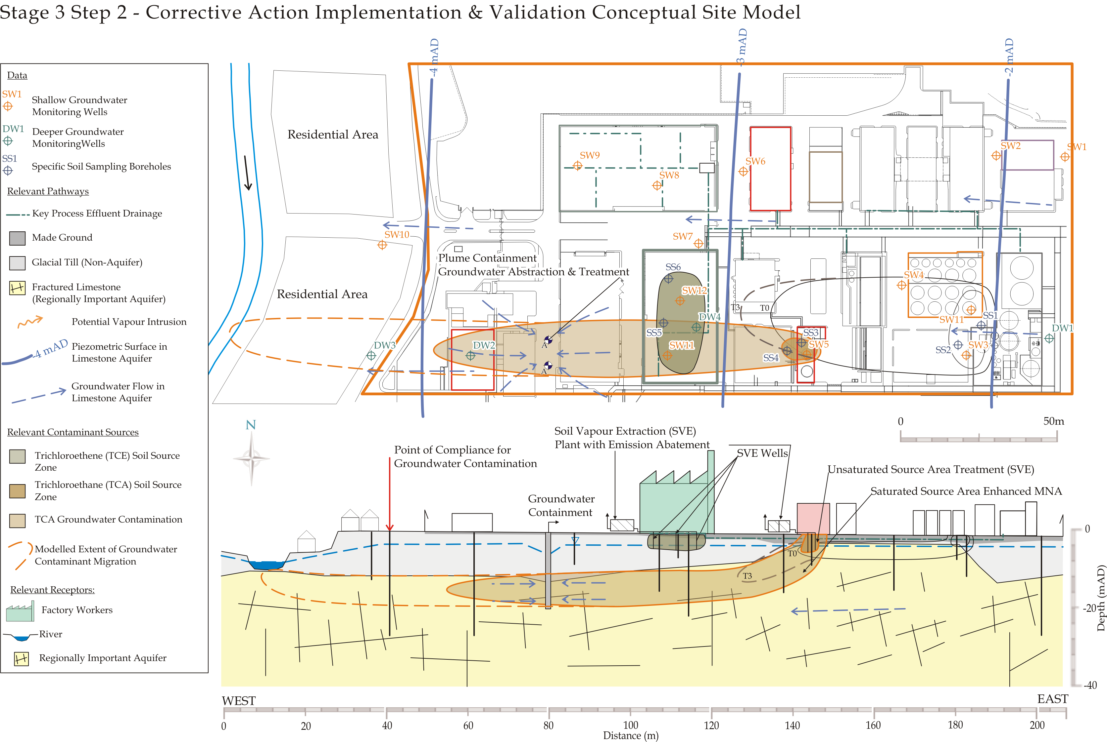
Replace this image with a diagrammatic Conceptual Site Model showing the current understanding of site circumstances.
EPA Contaminated Land & Groundwater Risk Assessment Methodology |  | Report Reference | Report Date | Status
STAGE 1: SITE CHARACTERISATION & ASSESSMENT
1.1 | PRELIMINARY SITE ASSESSMENT | (Insert previous report author & reference) | (Insert previous report date) | (Draft, Final, Approved, etc.)
1.2 | DETAILED SITE ASSESSMENT | (Insert previous report author & reference) | (Insert previous report date) | (Draft, Final, Approved, etc.)
1.3 | QUANTITATIVE RISK ASSESSMENT | (Insert previous report author & reference) | (Insert previous report date) | (Draft, Final, Approved, etc.)
STAGE 2: CORRECTIVE ACTION FEASIBILITY & DESIGN
2.1 | OUTLINE CORRECTIVE ACTION STRATEGY | (Insert previous report author & reference) | (Insert previous report date) | (Draft, Final, Approved, etc.)
2.2 | FEASIBILITY STUDY & OUTLINE DESIGN | (Insert previous report author & reference) | (Insert previous report date) | (Draft, Final, Approved, etc.)
2.3 | DETAILED DESIGN | (Insert previous report author & reference) | (Insert previous report date) | (Draft, Final, Approved, etc.)
2.4 | FINAL STRATEGY & IMPLEMENTATION PLAN | (Insert previous report author & reference) | (Insert previous report date) | (Draft, Final, Approved, etc.)
STAGE 3: CORRECTIVE ACTION IMPLEMENTATION & AFTERCARE
3.1 | ENABLING WORKS | (Insert previous report author & reference) | (Insert previous report date) | (Draft, Final, Approved, etc.)
3.2 | CORRECTIVE ACTION IMPLEMENTATION & VERIFICATION | (Insert this report author & reference) | (Insert this report date?) | (Draft, Final, etc.)
3.3 | AFTERCARE

- introduction
  - GENERAL INTRODUCTION
Confirm the contractual basis for the work including the proposal reference number.
List the name and role of the main people who completed the work and their qualifications and years of experience, including the main subcontracted elements, if applicable (i.e. sub-consultants; drilling contractor; specialist remediation contractor; laboratory analysis).
  - BACKGROUND INFORMATION
This section should succinctly inform the reader what the report is about. It should provide the licensee/site name, its location with reference to a site map and the activity at the site.
Summarise all key background information relevant to the project, referring to the key findings of Stage 1 in the above flow chart, and summarising the works completed during Stage 3, Step 1 (Construction/Enabling Works).
  - PROJECT OBJECTIVES
Clearly define the project objectives and their basis, referring back to key assumptions made within Stage 2. Describe the pollutant linkages that the Stage 3 corrective action was designed to address.
  - OUTLINE SCOPE OF WORKS
Summarise the scope of works that was developed to meet the defined project objectives, making reference in particular to the Stage 2, Step 4 (Final Strategy & Implementation Plan).
List the main tasks completed in bullet-point form and the period over which the tasks were undertaken, comparing this with originally expected time-frames and/or milestones.
Include details of any regulatory licences and/or permits that were required for the works.
Describe any significant variation from the implementation plan and verification plan and justify these variations.
- DETAILED SCOPE OF WORKs
Describe the remedial technologies adopted for the project and how these technologies were applied at the subject site.
Describe how the project was managed, in terms of operation, monitoring and maintenance of the remedial systems.
Describe the overall monitoring and verification plan, in terms of the number and locations of monitoring points, the frequency of monitoring and the reporting regime.
- System Performance
Describe in detail how the corrective action programme progressed compared with what was envisaged at detailed design stage. Include details of any changes made to optimise system performance, and also any problems that were encountered and how these were overcome.
Summarise any periods of significant system down-time and the reasons the system shut down. Describe any significant maintenance works completed, and why these were necessary.
- MONITORING RESULTS
Present a summary of the monitoring data collected during implementation of the corrective action programme. Make reference to figures and/or graphs that demonstrate progress towards the remedial objectives over time. Where appropriate explain what actions were taken in response to monitoring data that indicated poor system performance.
If interim monitoring reports were issued, ensure all the interim reports are referenced in this report. Present a high-level summary of the results contained within the interim reports and include any significant actions taken in response to the monitoring data received. The summary should include monitoring data in tabular and/or graphical form showing, for example, improvements in concentrations and mass removal with time (by contaminant of potential concern (COPC) or COPC group).
- VerificatION
Present a summary of the final verification data collected following completion of the corrective action programme, comparing the results with the objectives presented in the verification plan prepared at the end of Stage 2. Verification data collected at a point in time post corrective action is appropriate for certain aspects, such as confirming that soil quality in a source area has met the remedial targets. However, for aspects such as groundwater, a data set collected over a longer period, up to and including completion of corrective action, is usually needed to confirm sustained downward trends.
Make use of figures and/or graphs to demonstrate that the objectives of the corrective action programme have been met.
A clear statement concluding that the objectives have been met should be included in this section.
- REINSTATEMENT
This section of the report should include details of reinstatement works, including the methodology used to decommission wells (as appropriate). It should include a description of the condition of the site at completion (supported by a photographic record as needed).
Any structures and/or infrastructure remaining at the site following completion of the works should be described.
- AFTERCARE PLANNING
Within this section of the report, an assessment should be made of the potential impact of the site on controlled waters in its remediated state, and any further works that may be required (for example during site development) to protect receptors.
In most cases, a programme of post corrective action verification monitoring will have been included in this report. However the scope of the aftercare programme may have changed following completion of the main active phase of the corrective action programme. This will typically be discussed and agreed with the regulator following their review of the verification results.
If an Aftercare Report is considered necessary, then outline details of the proposed aftercare programme should be included in this section of the report and/or reference should be made to a separate aftercare proposal, which will include full details of the Aftercare Plan.
If a specific aftercare reporting exercise is not considered necessary, then full details of any planned aftercare programme should be included in this section of the report and this can be reported as part of the site Annual Environmental Report (AER) for as long as is required.

- liaison with the regulator and third parties
Include a summary of any discussions with the regulator and third parties, and any actions taken in response to these discussions.
Include any significant communications with the regulator (including in particular their agreement that the remedial objectives have been met) and third parties in an appendix.
Make reference to any meetings where key decisions were made (e.g. agreement that the objectives have been met; agreement to scope of post-verification monitoring programme).
- CONCLUSIONS & RECOMMENDATIONS
The concluding statement should state that the objectives of the corrective action programme have been met, based on the verification data collected.
Any recommendations, including outline details of any aftercare programme and/or whether an Aftercare Report is to be prepared, should be included in this section of the report.
oo0oo
Respectfully submitted
On behalf of Consultant Name

Sign Here

(Project Manager/Project Director/Lead Consultant)

