LICENCE REFERENCE No. | RISK ASSESSMENT METHODOLOGY STAGE & STEP |  | REPORT VERSION
Insert licence reference number | Insert methodology stage and step, e.g. Stage 1 Step 2 |  | Insert report version no., e.g. Draft, Final
INSERT COMPANY LOGO/HEADER
Guideline Template for Groundwater Monitoring Report
for the Environmental Protection Agency
(Month Year)
(LICENCE No.)

INSTRUCTIONS on use of this template
                - This document presents a guideline reporting template for stakeholders to use when reporting groundwater monitoring and related data under the EPA Contaminated Land & Groundwater Risk Assessment Methodology. It is designed to assist stakeholders with the submission of the correct information in a suitable format to the EPA. It should be regarded as a comprehensive guide; it is not intended as a wholly prescriptive template.
                - Where there are deficiencies or uncertainties in the information provided these should be clearly marked and annotated to indicate where further data gathering may be required.
                - In the template, those parts written in red indicate where relevant information and/or assessment should be entered. In entering this information the red text should be deleted or written over and the text reformatted to normal style.
                - For a glossary of terms and acronyms used in this template report and for a list of key technical guidance documents, refer to the ‘Guidance on the Management of Contaminated Land and Groundwater at EPA Licensed Sites’ (EPA, 2013).
                - This template is also considered best practice guidance for general reporting and interpretation of groundwater monitoring results at EPA licensed sites.
                - Delete this page before submitting this report to the EPA.

Project Title: |  | Groundwater Monitoring Report
Licence No.  Project No: |  | (complete)  (complete)
Contract No. |  | (complete)
Report Ref: |  | (complete)
Status: |  | (Draft/2nd Draft/Final (examples))
Client: |  | (complete)
Client Details: |  | (complete)
Issued By: |  | (Consultancy company name and address)
Document Production / Approval Record
 | Name |  | Signature | Date | Position | % Input
Prepared by (consultant) | Insert here |  | Insert here | Insert here | Insert here | Insert here
Approved by (consultant) | Insert here |  | Insert here | Insert here | Insert here | Insert here
Site Approval by | Insert here |  | Insert here | Insert here | Insert here | N/A
Limitation
                - All limitations that apply to the work should be summarised here, including reference to the original proposal for the work and the originally proposed project objectives and scope of works. State if these were achieved and the scope of works completed. Where the scope deviated significantly from the originally proposed scope, this should be summarised herein (if a limitation). State the limit of liability, reliance, etc., that apply to this project.

                - TABLE OF contents
Section |  | Page No
executive summary i
1. introduction 1
1.1. PROJECT CONTRACTUAL BASIS & PERSONNEL INVOLVED 1
1.2. BACKGROUND INFORMATION 1
1.3. PROJECT OBJECTIVES 1
1.4. SCOPE OF WORKS 1
1.4.1. rationale & strategy 1
1.4.2. GROUNDWATER sampling & monitoring 2
1.4.3. laboratory analyses 2
2. results & discussion of monitoring programme 2
2.1. site hydrogeology AND GROUNDWATER FLOW 2
2.2. GROUNDWATER RESULTS 3
2.3. potential pollutant linkages 3
3. SUMMARY, CONCLUSIONS AND RECOMMENDATIONS 3
3.1. SUMMARY AND CONCLUSIONS 3
3.2. RECOMMENDED WAY FORWARD 4
                - Update table of contents once all relevant report sections have been completed.
figures (to be expected)
Figure 1 | Site location plan
Figure 2 | Site layout plan showing main buildings and infrastructure including historical operational information and infrastructure (as relevant) and main hazardous chemical (waste) areas (storage, use, etc.)
Figure 3 | Relevant site plan showing groundwater monitoring well locations (including monitoring wells not sampled as part of this sampling round)
Figure 4 | Site plan illustrating inferred hydrogeological flow regime(s) – so-called piezometric surface map with indicative groundwater flow directions
Figure 5 | If relevant, site plan showing previous contamination distribution if this is post corrective action monitoring
Figure 6 | Site plans showing current groundwater (water) concentrations by monitoring well (other) location/depth (split as needed into key compound or chemical groups)
Figure 7 | Up-to-date Conceptual Site Model (CSM) (can be previous and current versions of CSM if this is the best way to illustrate a change; in all cases the CSM should be illustrated in diagrammatic form)
Tables (to be expected)
Table 1 | Groundwater (or other media, e.g. surface water) sampling and laboratory analysis inventory
Table 2 | Well inventory confirming year of installation, installed well base depths, internal diameter, depth of screened section, condition of groundwater wells and whether any repair or maintenance work is needed to secure such monitoring points
Table 3+ | Groundwater monitoring information (water levels as depth below reference datum and as mAOD; measured depth to well base versus installed depth; purged volumes, field observations during sampling, wellhead measured field parameters)
Table 4+ | Summaries of key chemical analysis results for groundwater by area and/or chemical group
Table 5+ | Site ground gas monitoring information (concentrations, pressures, flows, etc.) if relevant to subject site
appendices (that may be expected to be useful)
Appendix A | Laboratory analysis certificates (laboratory signed-off versions)
Appendix B | In the case of a routine monitoring programme, present a series of graphs of key data, for key wells or areas of the site, for all the main Contaminants of Potential Concern (COPC)
Appendix C  Appendix D | Monitoring well construction and associated borehole drilling logs for all sampled installations  If post corrective action monitoring, information on this programme and a summary of previous verification data (taken from previous reports)

executive summary
An Executive Summary is considered necessary for all reports of any size to allow a reader to quickly understand project objectives and scope of work and all the main findings.
This must include as a separate page within the executive summary the latest diagrammatic Conceptual Site Model (CSM) based on data collected during this phase of the site programme of works.
It must also include a flow chart illustrating how far the site programme has gone within the overall contaminated land and groundwater site assessment and corrective action process (see attached), of which this monitoring report forms a part.
This executive summary text must state where this groundwater monitoring exercise sits with respect to the overall programme. For example it could be Stage 1 or post Stage 1 groundwater monitoring or monitoring linked to support of Stage 2 or Stage 3.
The flow chart must confirm all aspects already completed (see attached example).

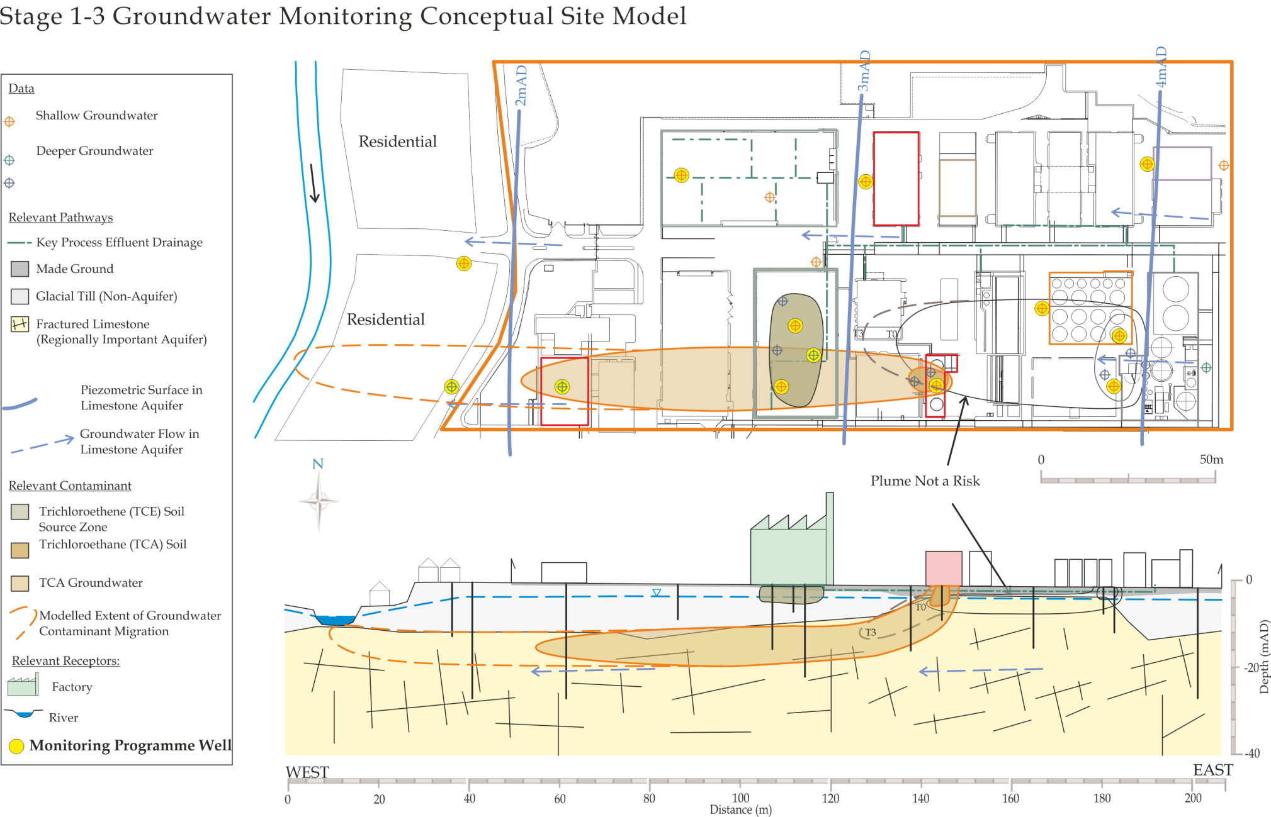
Replace this image with a diagrammatic Conceptual Site Model showing the current understanding of site circumstances.
EPA Contaminated Land & Groundwater Risk Assessment Methodology |  | Report Reference | Report Date | Status
STAGE 1: SITE CHARACTERISATION & ASSESSMENT
1.1 | PRELIMINARY SITE ASSESSMENT | (Insert previous report author & reference) | (Insert previous report date) | (Draft, Final, Approved, etc.)
1.2 | DETAILED SITE ASSESSMENT | As above (as appropriate) | As above (as appropriate) | As above (as appropriate)
1.3 | QUANTITATIVE RISK ASSESSMENT | As above (as appropriate) | As above (as appropriate) | As above (as appropriate)
STAGE 2: CORRECTIVE ACTION FEASIBILITY & DESIGN
2.1 | OUTLINE CORRECTIVE ACTION STRATEGY | As above (as appropriate) | As above (as appropriate) | As above (as appropriate)
2.2 | FEASIBILITY STUDY & OUTLINE DESIGN | As above (as appropriate) | As above (as appropriate) | As above (as appropriate)
2.3 | DETAILED DESIGN | As above (as appropriate) | As above (as appropriate) | As above (as appropriate)
2.4 | FINAL STRATEGY & IMPLEMENTATION PLAN | As above (as appropriate) | As above (as appropriate) | As above (as appropriate)
STAGE 3: CORRECTIVE ACTION IMPLEMENTATION & AFTERCARE
3.1 | ENABLING WORKS | As above (as appropriate) | As above (as appropriate) | As above (as appropriate)
3.2 | CORRECTIVE ACTION IMPLEMENTATION & VERIFICATION | As above (as appropriate) | As above (as appropriate) | As above (as appropriate)
3.3 | AFTERCARE | As above (as appropriate) | As above (as appropriate) | As above (as appropriate)

- introduction
  - PROJECT CONTRACTUAL BASIS & PERSONNEL INVOLVED
Confirm the contractual basis for the work including the proposal reference number.
List the name and role of the main people who completed the work and their qualifications and years of experience, including the main subcontracted elements, if applicable (e.g. sub-consultants; laboratory analysis).
  - BACKGROUND INFORMATION
This section should succinctly inform the reader what the report is about. It should provide the licensee/site name, its location with reference to a site map and the activity at the site.
Summarise background information relevant to the site monitoring programme, such as the main findings of works completed previously. This may include Stage 1, 2 and/or 3 information. Reference reports already issued, as required, but do not use this to exclude providing useful background information herein. Relevant information from the Stage 1 element that should be summarised herein is expected to include the following:
- Existing understanding of site history/operations/layout;
- Geology and hydrogeology;
- Site areas of land and/or groundwater contamination or potential contamination, specifically those that are the main form of the monitoring;
- The nature of associated potential pollutant linkages and the main potential risk drivers linked to actual or potential land and groundwater contamination at the site;
- A summary of borehole drilling and associated monitoring well design and construction information (for installations sampled as a minimum).
Use site plan(s) to illustrate key information in the context of the groundwater (other) monitoring network.
Tabulate and/or append existing relevant information such as exploratory borehole logs and monitoring well age and construction, geological cross-section(s), time serial groundwater level and quality data for key monitoring wells (focusing on Contaminants of Potential Concern (COPC)). These should typically be attached as figures or appended material. In certain circumstances it may be adequate to refer to previous reports, if recently submitted and readily available to the Agency (must clearly reference the report including title, author, date, reference, figure/table/appendix number and page).
The latter should not be the default position as each groundwater monitoring report should in itself contain all the necessary information to allow ready interpretation of the results and findings.
  - PROJECT OBJECTIVES
Confirm the project objectives as previously outlined or established prior to this phase of work commencing.
  - SCOPE OF WORKS
    - rationale & strategy
Describe the monitoring (sampling) strategy and what techniques were selected to implement this and why. Use the CSM to justify these decisions. This section should include detail on the following:
- The rationale and objectives of sampling;
- Justification for the number and location of monitoring positions;
- Justification for parameters included in the monitoring programme.
Different drivers active in different parts of a site may influence the scope of the groundwater (or other) monitoring and sampling. This should be captured here such that the decisions underpinning the monitoring programme are, from the outset, understood and communicated.
All monitoring well (or other media) locations must be illustrated on a suitably scaled and orientated site plan (Figure 3).
    - GROUNDWATER sampling & monitoring
Use this section to describe how sampling and/or monitoring were undertaken of groundwater (or other media, e.g. surface water if relevant). Provide detail on the following:
- Water level monitoring (to be completed prior to sample collection);
- Collection of wellhead parameters (e.g. pH, electrical conductivity, temperature, redox potential, dissolved oxygen) and the techniques and instruments used to measure these;
- Sampling techniques and protocols (well volumes purged);
- Sample containers/bottles used;
- Filtering and preservation protocols (mainly needed for waters);
- Dates and number of monitoring events undertaken (waters/gases/vapours only);
- Sample handling protocols (uniquely labelled, refrigerated, use of cool boxes with frozen ice packs, logged onto chain of custody form, how delivered to laboratory, etc.).
    - laboratory analyses
Summarise information on laboratory analyses including:
- Confirm timing and condition of samples upon receipt at the laboratory undertaking the analysis (and how long they were in transit);
- Which laboratories were subcontracted, status of laboratory accreditation for the sample types and analyses (groups) performed;
- What analyses were scheduled and the numbers of samples analysed;
Tabulate a comprehensive sample analysis inventory (by sample type if relevant) – typically Table 1.
- results & discussion of monitoring programme
  - site hydrogeology AND GROUNDWATER FLOW
Infer and describe the hydrogeological regime from groundwater and surface water monitoring data, and the understanding of site geology. Specifically provide detail on the following:
- Which geological media contain groundwater;
- What is the local Groundwater Body (GWB) and to what extent has it been investigated;
- The inferred direction(s) of groundwater flow (considering potential vertical as well as horizontal flow), including details of how the wellhead elevations were established;
- Features in the groundwater flow field (mounded groundwater levels, flow divide, boundary effects, sources/sinks, etc.);
- Likely degree of interaction between groundwater and surface water;
- The apparent governing flow regime – inter-granular, fissure-flow;
- Hydraulic parameters – hydraulic conductivities, hydraulic gradients, estimated groundwater flow velocity, travel time to potential receptor, etc.
Use contoured site plans and cross-sections to illustrate the site hydrogeology, as needed. Tabulate and/or append groundwater/surface water monitoring data.
  - GROUNDWATER RESULTS
Use this section and additional sub-sections to describe and relate observed groundwater contamination to site operational history and previous site investigation and monitoring findings. Describe and relate contamination, where appropriate and as required, to the following, e.g. by source zone, by site operational area, by contamination type or geological/hydrogeological unit – use the CSM and sampling strategy to guide this decision. Specifically the following should be presented and discussed:
- The nature, magnitude and extent of COPC and other key parameters including indicator parameters of redox conditions;
- Groundwater COPC trends with time; is the plume stable to declining, or spreading? Consider mass flux estimates as well as concentration data;
- Discuss evidence for transfer/interactions between different phases in the system – leaching, migration in groundwater, etc. – and to what degree natural attenuation appears to be occurring;
- Relate this to the previous phase CSM (historical land use, for example).
Tabulate and/or append key data. Annotate site plans and/or geological cross-sections to illustrate the chemical character, magnitude and extent of groundwater (or other medium) contamination, as needed.
  - potential pollutant linkages
Summarise the updated CSM of pollutant linkages here with reference to the findings and discussion of the groundwater (or other medium) monitoring results provided.
- SUMMARY, CONCLUSIONS AND RECOMMENDATIONS
  - SUMMARY AND CONCLUSIONS
This section must bring together all the above information in a concise and clear way so that the reader is able to understand the findings of the site monitoring programme (recent and over time) and what decisions if any have been made with respect to the potential pollutant linkages identified. This will be the case particularly if the data suggests the groundwater condition is deteriorating or there is any form of “new” contamination. It is also expected to be the case if the existing monitoring network does not appear to be adequate for the scale and nature of site operations and/or if operational changes are expected to take place.
Summarise the updated CSM of pollutant linkages again here and use technical diagrams to illustrate this. Place a copy of the updated conceptual site model diagram at the end of the Executive Summary of this report.
If the data suggests a worsening condition over time then the updated CSM should be used to develop a focused action plan. If there is a sustained improvement then the scope of monitoring may be reduced, provided it can be clearly demonstrated. If the site appears to be no longer contaminated and again it can be demonstrated that the monitoring network is appropriate, it may be acceptable to cease groundwater monitoring altogether at least for the foreseeable future.

  - RECOMMENDED WAY FORWARD
A groundwater monitoring report should not be seen as a routine exercise that requires little thought or expertise. Groundwater or the surface water it interacts with is a precious resource that requires protecting. Therefore the results of the monitoring programme need to be considered in the context of whether any additional action should be considered or is required.
Fundamentally the monitoring programme and results should be assessed to ensure the programme is still relevant and appropriate, and suitably designed and implemented (and wells suitably maintained).
The decision on a recommended way forward will depend on where the site is with respect to the overall investigation, assessment (and corrective action) programme. In some cases, where the due process has been followed, scope reduction may be sought (i.e. reduction or cessation of monitoring). In other cases the monitoring data may be informing the decision-making process with respect to risk assessment findings or proposed corrective action needs.
This section may be expected to include:
- Confirmation of the suitability of the monitoring programme going forward and any changes that may be considered appropriate in terms of monitoring points, frequency of monitoring, and COPCs/other parameters included in the analytical schedule;
- Confirmation of whether and why the monitoring network is adequate to define the site groundwater (or other medium) condition in its current context;
- Whether additional investigations or a change of emphasis are needed to better understand the nature, magnitude and extent of relevant source zones and/or pathway and/or receptor characteristics;
- The requirement for potential corrective action at the site or confirmation of what is already in place.
oo00oo
Respectfully submitted
On behalf of Consultant Name

Sign Here

(Project Manager/Project Director/Lead Consultant)

