Licence Application Guidance

How to access and respond to an EPA Notice issued to EDEN

Purpose
This guidance document has been created to assist applicants to access and respond to an EPA noticed issued on a licence application/review via the Environmental Data Exchange Network (EDEN) online portal.
From 25th October 2018, the EPA will communicate with the applicant or licensee associated with an Industrial Emissions (IE), Integrated Pollution Control (IPC) or Waste licence application/review via the EDEN portal only.
If you have a query on how to respond to a EPA notice issued via EDEN, please submit it to: licensing@epa.ie.

How to access and respond to an EPA Notice issued via EDEN
To access and respond to an EPA Notice issued via EDEN please follow the steps outlined below:
1.(a) Click on the ‘Click here’ link in the e-mail you receive.
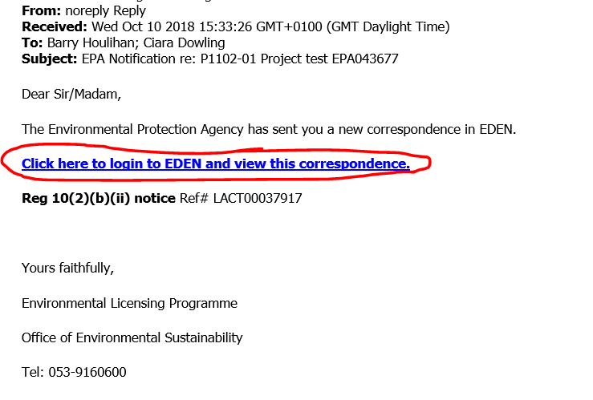
OR
1.(b) Access the Licence Application record via EDEN

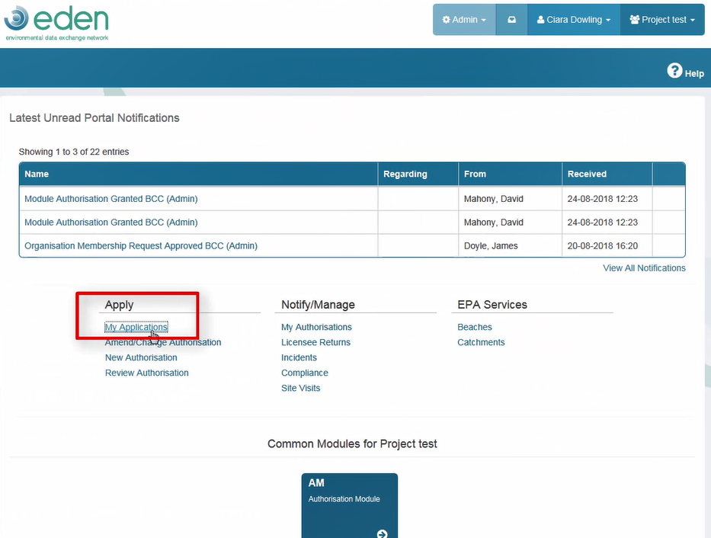

1.(c) Click into the Licence Application ‘Dashboard/Application No.’.
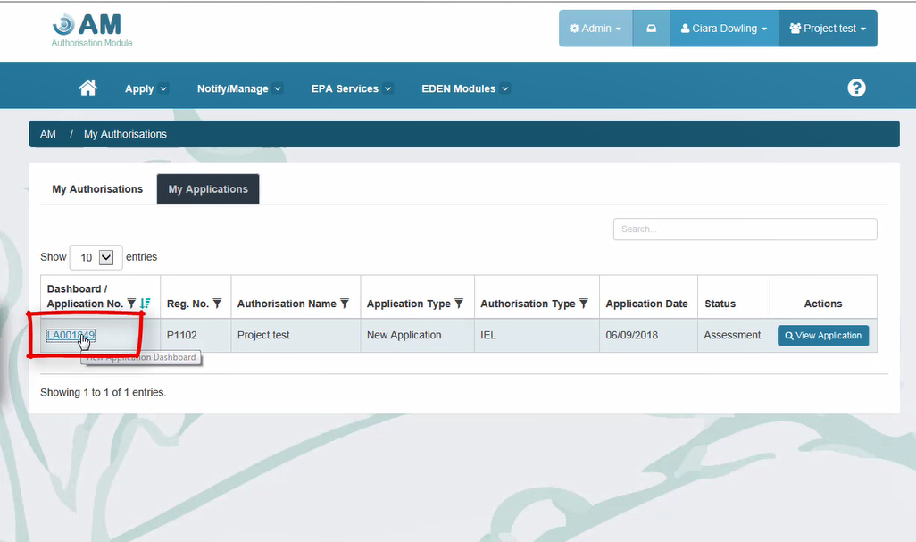
1.(d) Notices issued by the EPA will be visible in the ‘Notifications’ area. (Unread notices are displayed in bold. Notices requiring a response have an ‘Action Required’ status)
Double click on the notice ‘Title’ to view and open the notification details.

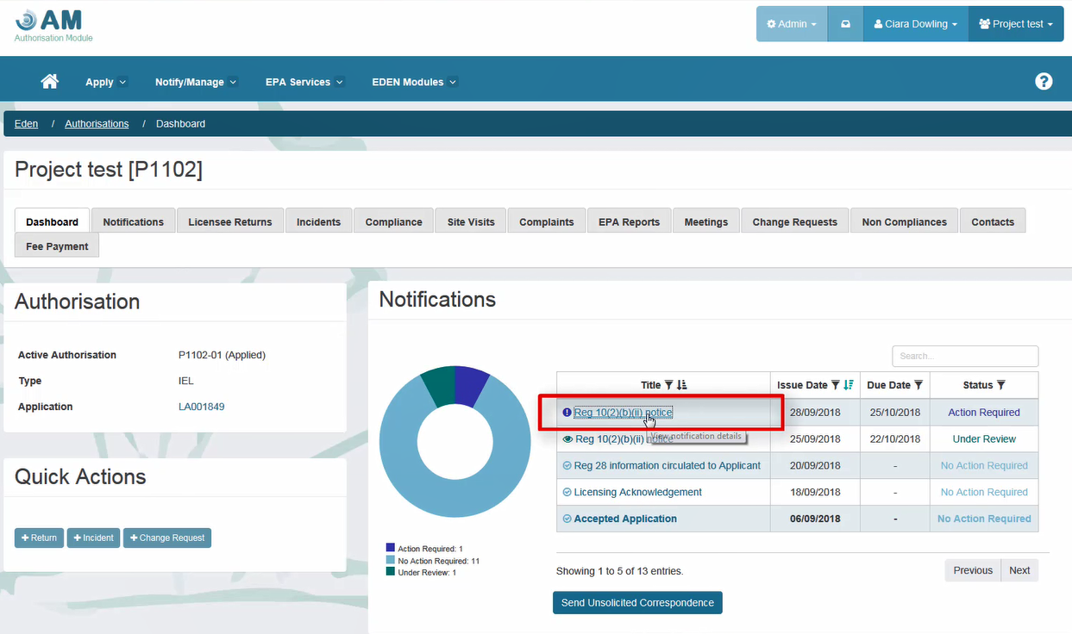

- Click on the ‘Download’ button to open the EPA notice.

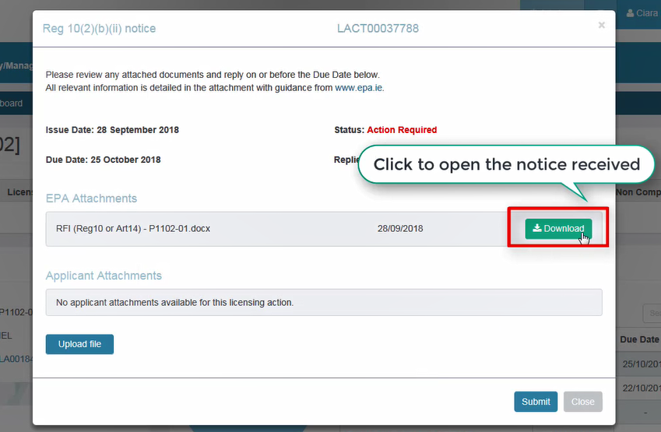

- Read notice and where required prepare response document(s).
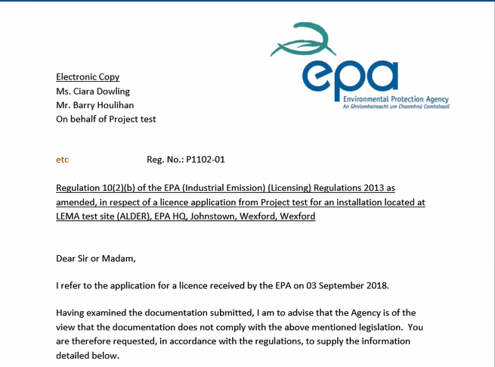

- Click on the ‘Upload file’ button to upload the response (in PDF format).
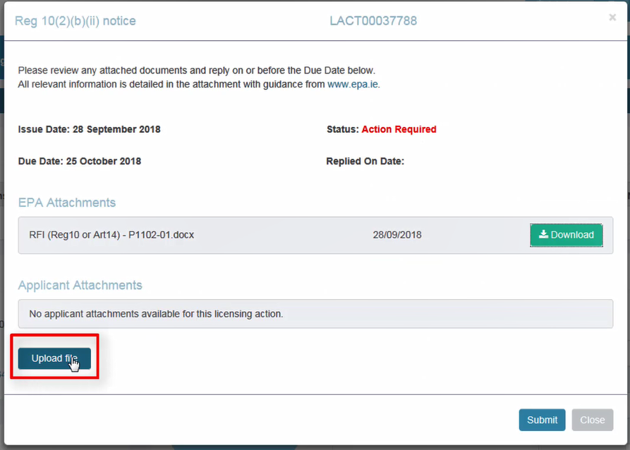
- Click on the response and click on ‘Open’. Repeat for any additional response document(s).
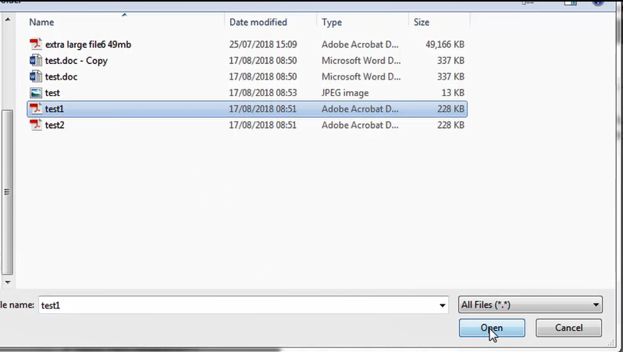

- The uploaded files will be visible in the ‘Applicant Attachments’ section.
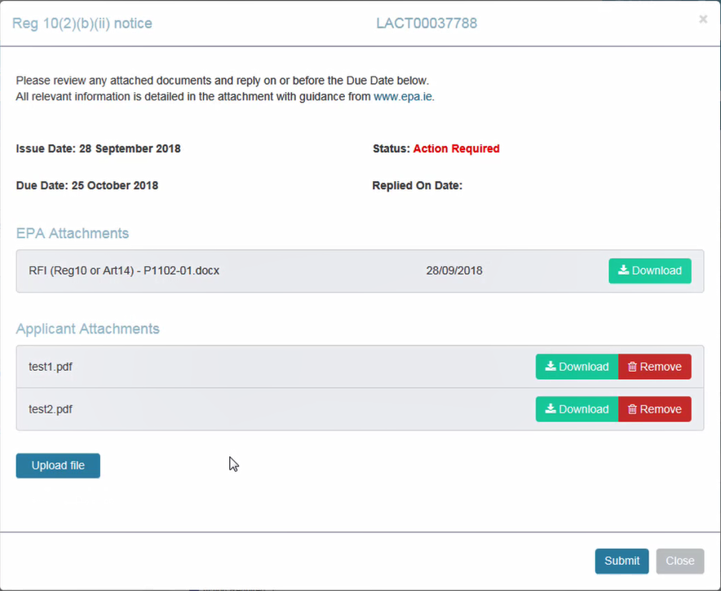
- When the response file(s) are finalised and uploaded, click on ‘Submit’ to send the response to the EPA.
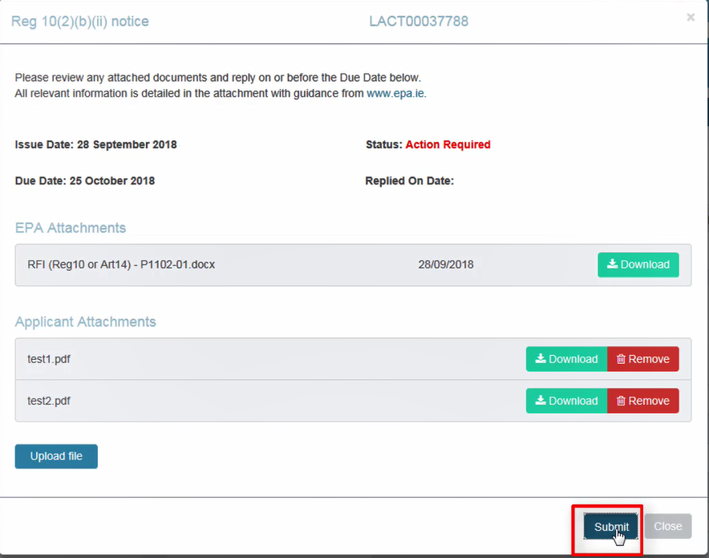
- If successful, you will see a ‘Thank You’ message and a ‘Replied on Date’ will be visible.
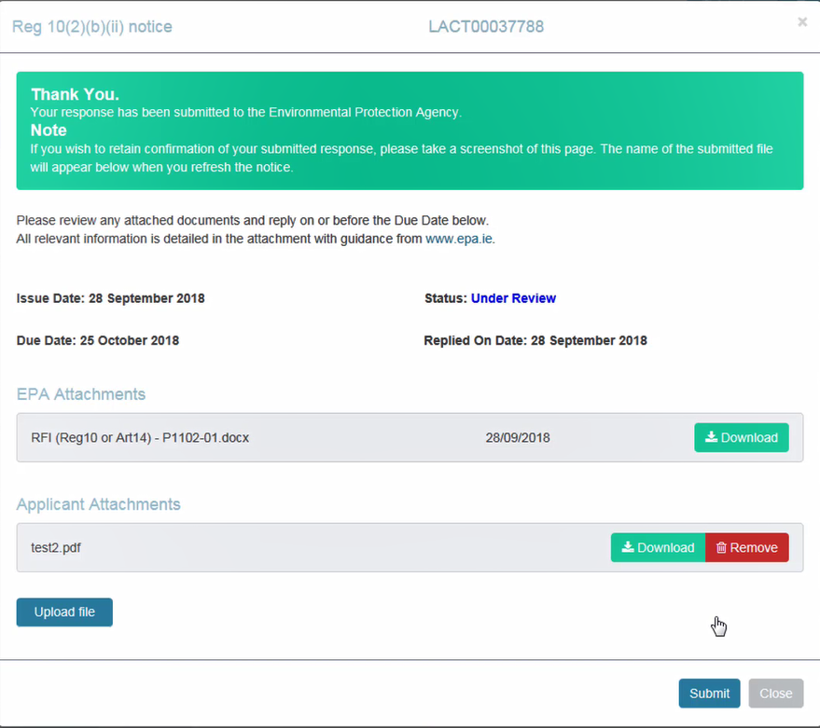
- Click on ‘Close’ to leave this page.
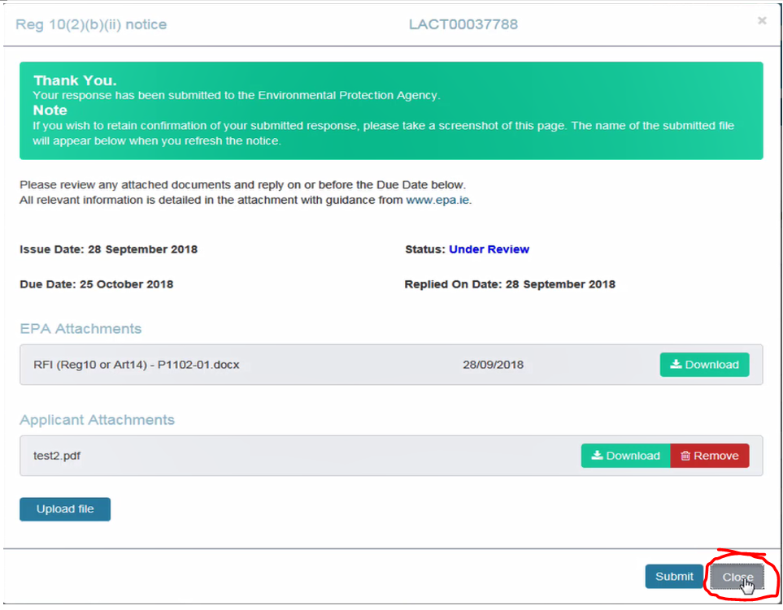
- The EPA will assess your response and will contact you in due course.

