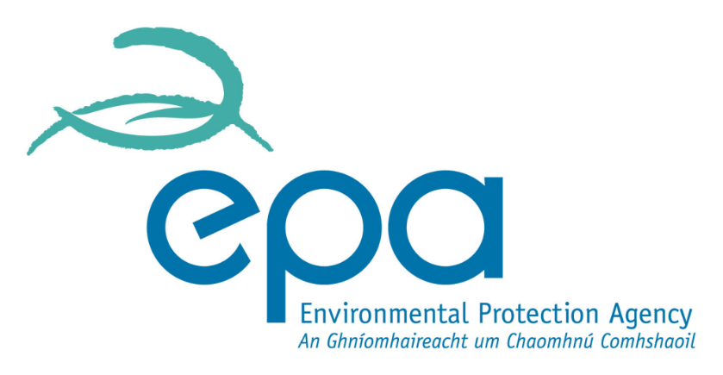

Request for Assistance under Regulation 9(2)

Waste Management (Management of Waste from the Extractive Industries) Regulations, 2009 – S.I. 566

EPA Ref. Nº:
(Office use only)

Environmental Protection Agency
PO Box 3000, Johnstown Castle Estate, Co. Wexford
Lo Call: 1890 335599 Telephone: 053-9160600
Web: www.epa.ie Email: ExtractiveIndustriesRegister@epa.ie

CONTENTS

CONTENTS 2
request form GUIDANCE NOTES 3
SECTION A: NON-TECHNICAL SUMMARY 4
SECTION B: GENERAL 5
SECTION C: SITE DETAILS 6
SECTION D: RISK ASSESSMENT 8
SECTION D: DECLARATION 9
SECTION E: JOINT DECLARATION 10

REQUEST FORM GUIDANCE NOTES

This form must be completed in accordance with the guidance notes below and the instructions accompanying each section of the application form.

This form is for the purpose of requesting assistance by a Local Authority in accordance with regulation 9(2) of the Waste Management (Management of Waste from the Extractive Industries) Regulations, 2009 (hereinafter referred to as ‘the Regulations’), in relation to the classification of an extractive waste facility.

It should be noted that regulation 9(2) relates to a ‘waste facility’ as defined in regulation 3(2) of the Regulations. The timeframes set out therein should be noted.

The applicant should conform to the format set out in this form and accompanying instructions. Each page of the completed form must be numbered, e.g. page 5 of 20, etc. The basic information should be supplied in the spaces given in the application form, with supporting documentation supplied as attachments, as specified. All sections of the form must be completed. Where a section is not relevant to the application, the words “not applicable” should be clearly written. The abbreviation “N/A” should not be used.

The risk assessment carried out for the purpose of the classification should be submitted in full as Attachment D.1 to this form. The advice circular issued by the Department of Environment, Heritage and Local Government (No WP 24/10) should be consulted on the matter.

All maps/drawings/plans must be no larger than A3 size and scaled appropriately such that they are clearly legible. In exceptional circumstances, where A3 is considered inadequate, a larger size may be requested by the Agency.

All drawings should:

- be titled and dated;
- have a unique reference number and be signed by a clearly identifiable person; and
- indicate a scale and the direction of north.

Information supplied on this form, including supporting documentation, will be available for public display and open to inspection by any person.

An original signed version (and any accompanying documentation) shall be submitted in searchable PDF format.

It should be noted that it will not be possible to process or determine the request until the required documents have been provided in sufficient detail and to a satisfactory standard.

This document does not purport to be and should not be considered a legal interpretation of the provisions and requirements of the Waste Management (Management of Waste from the Extractive Industries) Regulations, 2009.

SECTION A: NON-TECHNICAL SUMMARY

A non-technical summary is to be included here. The summary should identify all environmental risks and impacts of significance associated with the waste facility and should clearly state the local authority’s opinion on the most appropriate classification of the facility.

The following information must be included in the non-technical summary:

A brief description of:

- The location of the waste facility.
- A brief history of the facility, the nature of the associated extraction activity, types and volumes of waste deposited, duration of deposition and date of cessation (if applicable).
- A brief description of the surrounding environment.
- Actual and potential environmental risks and impacts.
- A reasoned opinion as to the most appropriate classification for the waste facility.
- The reasons as to why the request for assistance is being made and why a definitive classification for the waste facility cannot be made.

Any supporting information should form Attachment A.1.

SECTION B: GENERAL

B.1. Details of the local authority requesting assistance

Name:*
Address:
Tel:
Fax:
e-mail:
*Full name and address of the local authority making the request.

Contact details for Correspondence

Name:*
Local authority:
Address:
Tel:
Fax:
e-mail:
*This should be the name of the person nominated by the local authority for the purposes of this request.

Co-Applicant’s Details
Name:*
Address:
Tel:
Fax:
e-mail:
*This should be the name of a local authority, other than the lead authority, where a site lies in more than one local authority functional area.

SECTION C: WASTE FACILITY DETAILS

C.1. Waste Facility Location

Name:
Address:*
Name of contact at the waste facility:
Tel:
Fax:
e-mail:
* Include any townland

Attachment C.1. should contain appropriately scaled drawings or maps (≤A3) showing the location of the waste facility (and any associated extraction site) in the context of its surroundings and clearly highlighting the facility and site boundary.

C.2. Extractive Industries Register

This relates to the registration of extractive industries (i.e., sites of extraction) as required by regulation 19(1) of the Regulations.

State whether the extraction site associated with the waste facility in question has been registered on the regulation 19(1) online register at http://www.epa.ie/whatwedo/enforce/pa/extractiveindustriesregister/
and that the boundary drawn of the site on the register represents the full extent of the site.

Finalised boundary of extraction site saved into Extractive Industries Register?

- Provide the unique code assigned to the extraction site in the online register that is associated with the waste facility in question.

Site Code

C.3. Classification as per Regulation 9(1)

State whether or not the waste facility is considered by the local authority to be Category A:

Category A
Non-Category A

Where non-category A, state whether the facility is considered to be either:

Non-hazardous, non inert
Inert, non-polluting

Provide a reasoned opinion for the classification of the waste facility as stated above.

State why regulation 9(2) is being utilised (i.e. reasons for doubt regarding above classification).

Supporting information should form Attachment C.3.

SECTION D: RISK ASSESSMENT

The risk assessment must be carried out by a suitably qualified, competent and experienced person.

The advice circular issued by the Department of Environment, Heritage and Local Government (No. WP 24/10) should also be consulted on the matter.

The Risk Assessment should, as a minimum, include the following:

- A brief history of the waste facility.
- The nature of the associated extraction.
- The types and volumes of waste deposited at the facility.
- The duration of deposition and date of cessation (if applicable).
- A brief description of the surrounding environment.
- Actual and potential environmental risks and impacts.
- The most appropriate classification for the waste facility.

One copy of the risk assessment shall be submitted in searchable PDF format.

The Risk Assessment report should be submitted as Attachment D.1.

SECTION F: DECLARATION

Declaration

I hereby request assistance from the Environmental Protection Agency pursuant to regulation 9(2) of the Waste Management (Management of Waste from the Extractive Industries) Regulations (S.I. No. 566 of 2009).

I certify that the information given in this request is truthful, accurate and complete and that the enclosed risk assessment is a full and complete representation of all relevant work carried out in relation to the facility in question.

I give consent to the EPA to copy this request for its own use and to make it available for inspection and copying by the public, both in the form of paper files available for inspection at EPA offices and via the EPA's website.

This consent relates to this request itself and to any further information or submission, whether provided by me as Applicant, any person acting on the Applicant’s behalf, or any other person.

I recognise that any opinion expressed by the EPA on the classification of the waste facility will be based on the information provided by the local authority.

Signed by : Date :
(on behalf of the organisation)

Print signature name:

Position in organisation:

Note 1: The application should be signed by someone operating at a senior level within the organisation.

SECTION G: JOINT DECLARATION

Joint Declaration ^{Note1}
I hereby request assistance from the Environmental Protection Agency pursuant to regulation 9(2) of the Waste Management (Management of Waste from the Extractive Industries) Regulations (SI No. 566 of 2009).

I certify that the information given in this request is truthful, accurate and complete and that the enclosed risk assessment is a full and complete representation of all relevant work carried out in relation to the facility in question.

I give consent to the EPA to copy this request for its own use and to make it available for inspection and copying by the public, both in the form of paper files available for inspection at EPA offices and via the EPA's website.

This consent relates to this request itself and to any further information or submission, whether provided by me as Applicant, any person acting on the Applicant’s behalf, or any other person.

I recognise that any opinion expressed by the EPA on the categorisation of the waste facility will be based on the information provided by the local authority.

Lead Authority

Signed by : Date :
(on behalf of the organisation)

Print signature name:

Position in organisation:

Co-Applicants

Signed by : Date :
(on behalf of the organisation)

Print signature name:

Position in organisation:

Signed by : Date :
(on behalf of the organisation)

Print signature name:

Position in organisation:

Note 1: In the case of a request being lodged on behalf of more than one local authority the above declaration must be signed by all applicants.

